How to download masked Aadhaar?
To download masked Aadhaar, follow these steps:
- Visit myaadhaar.uidai.gov.in.
- Click on Login.
- Enter the Aadhaar number, Captcha and click on Send OTP.
- Enter the OTP received on the Aadhaar registered mobile number and click on Login.
- Click on Download Aadhaar.
- Click on Do you want a masked Aadhaar?
- Click on Download.
- Click on the downloaded file and enter the first four letters of your name as per Aadhaar in CAPITAL letters and year of birth in YYYY format.
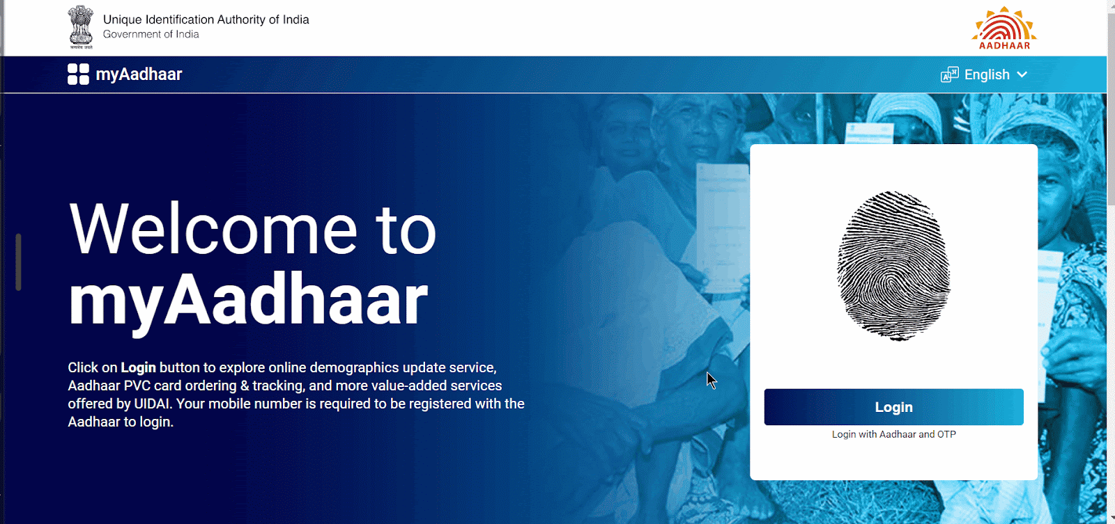
In the masked Aadhaar, only the last 4 digits are visible.
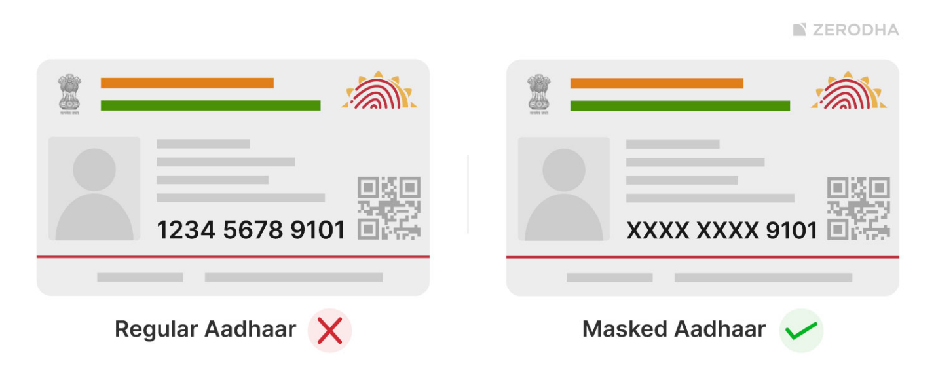
Clients who possess an Aadhaar with all 12 digits visible can still submit it with only the last 4 digits showing, as long as they mask the first 8 digits using a pen or marker.
How to download masked Aadhaar?
To download masked Aadhaar, follow these steps:
- Visit myaadhaar.uidai.gov.in.
- Click on Login.
- Enter the Aadhaar number, Captcha and click on Send OTP.
- Enter the OTP received on the Aadhaar registered mobile number and click on Login.
- Click on Download Aadhaar.
- Click on Do you want a masked Aadhaar?
- Click on Download.
- Click on the downloaded file and enter the first four letters of your name as per Aadhaar in CAPITAL letters and year of birth in YYYY format.
In the masked Aadhaar, only the last 4 digits are visible.
Clients who possess an Aadhaar with all 12 digits visible can still submit it with only the last 4 digits showing, as long as they mask the first 8 digits using a pen or marker.

