Angel One Limited



*Impact Assessment of Angel One CSR Programs*

March 2025

Contents

Introduction 4

About the Study 5

Approach 7

Methodology 9

Stage 1: Inception 9

Stage 2: Data Collection 11

Stage 3: Analysis and Delivery 12

Report Structure 13

Quality Assurance 14

Aajeevika Bureau Trust 15

Background and Context 15

About the Program 15

Study Objectives and Methodology 16

Key Findings 17

Recommendations 18

Conclusion 19

Raah Foundation 20

Background 20

About the Program 20

Study Objectives and Methodology 21

Key Findings 21

Recommendations 23

Conclusion 23

NIIT Foundation 24

Background and Context 24

About the Program 24

Study Objectives and Methodology 25

Key Findings 25

Recommendations 27

Conclusion 27

TRRAIN 28

Background and Context 28

About the Program 28

Study Objectives and Methodology 29

Key Findings 29

Recommendations 31

31

Conclusion 31

Kherwadi Social Work Association 32

Background and Context 32

About the Program 32

Study Objectives and Methodology 33

Key Findings 33

Recommendations 35

Conclusion 36

Shram Saarthi 37

Background and Context 37

About the Program 37

Study Objectives and Methodology 38

Key Findings 38

Recommendations 39

Conclusion 40

Raah Foundation 41

Background and Context 41

About the Project 41

Study Objectives and Methodology 42

Key Findings 43

Recommendations 44

Conclusion 45

# Introduction

Skill development serves as a crucial link between employment and the workforce. In our current era of globalization and rapid technological changes, enhancing skills is essential for improving workforce efficiency and productivity, which ultimately drives economic growth. It empowers individuals and communities, providing them with better opportunities for employment or equipping them to start their own businesses and create jobs for others.

However, achieving a successful skills development system requires careful alignment between the needs of industries (demand) and the capabilities of individuals (supply). This involves strong collaboration among the government, private sector, and training organizations. According to a report by Korn Ferry, over 85 million jobs could remain unfilled by 2030 due to a shortage of qualified candidates.[1] This issue stems from the disconnect between employers’ requirements and the skills that workers possess.

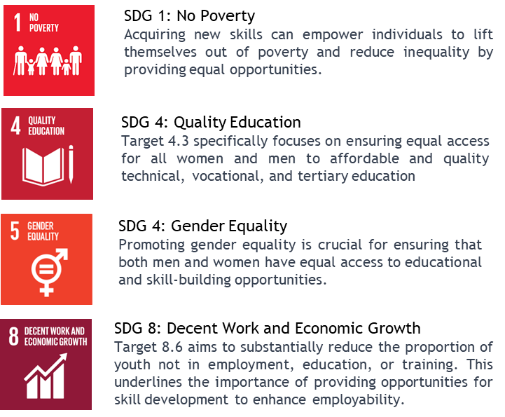Sustainable development requires tackling the issues of unemployment, poverty, and a lack of education in a world growing more interconnected by the day. Initiatives pertaining to skill development, education, and entrepreneurship are directly supported by the Sustainable Development Goals (SDGs) of the United Nations, specifically SDG 1 (No Poverty), SDG 4 (Quality Education), SDG 8 (Decent Work and Economic Growth), and SDG 9 (Industry, Innovation, and Infrastructure).

With more than 62 percent of the population in the working-age group (15-59 years) and more than 54 percent of the total population under the age of 25, India is now one of the world’s youngest countries. [2] However, only 2% of India’s total workforce has career-building skills.[3] The Government of India has introduced several schemes and programs to promote and enhance skill development across the nation ultimately paving the way for improved employment opportunities. Pradhan Mantri Kaushal Vikas Yojana was launched by the Ministry of Skill Development and Entrepreneurship in 2015. It aims to enable the Indian youth to take up industry-relevant skill training which would help them secure better livelihoods. Skill Acquisition and Knowledge Awareness for Livelihood Promotion SANKALP is a World Bank-supported program that was launched in 2018. It aims to improve short-term skill training qualitatively and quantitatively through strengthening institutions, improving market connectivity and inclusion of marginalised sections of society.

In line with SDGs 8 and 9, Maharashtra, one of India's top industrial states, places a high priority on developing entrepreneurial and vocational skills to satisfy the demands of a variety of industries (Government of Maharashtra, 2021)[4]. To address the high rates of unemployment and illiteracy, Rajasthan places a strong focus on women's entrepreneurship and community-based educational initiatives. The state's efforts, which seek to empower women via skill development, are in line with SDGs 4 and 5 (Gender Equality) (Government of Rajasthan, 2021)[5]. The state of Gujarat which is known for its culture of entrepreneurship, supports industry and innovation in line with SDG 9. Programs implemented by the state are intended to create an environment that supports new businesses and technology-driven educational initiatives (Government of Gujarat, 2021)[6].

Angel One is actively supporting a range of skill development and livelihood programs throughout India to address this important issue.

# About the Study

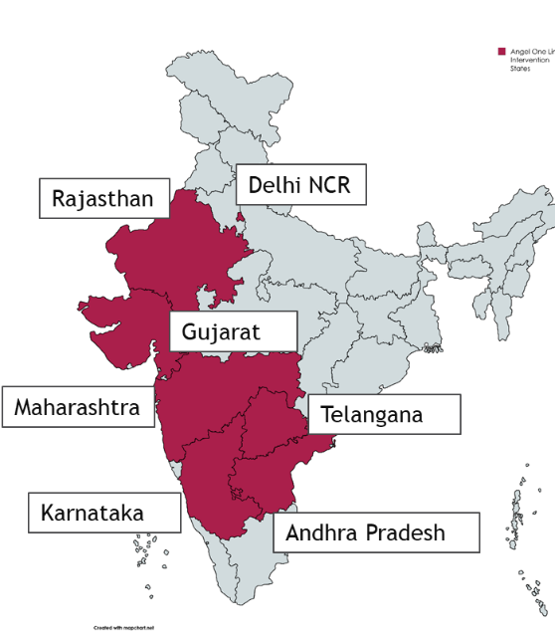Angel One's CSR objective is to empower underprivileged students by providing them with opportunities to enhance their skills, thereby enabling them to become economically independent and self-reliant. Angel One Limited has undertaken several initiatives focused on skill development and promoting digital and financial literacy among youth, empowering them to integrate seamlessly into the formal employment sector. It covered the following geographies in the country:

* Delhi NCR
* Rajasthan
* Gujarat
* Maharashtra
* Karnataka
* Andhra Pradesh
* Telangana

The projects aimed at entrepreneurship, education and livelihood and skill development aiming to improve the lifelong opportunities and enabling them to seek productive employment, decent work for all and consistent, inclusive and economic growth. The projects also assist in creating resilient infrastructure, advance equitable and sustainable industrialization, and encourage innovation.

In line with the program's objectives, Angel One is conducting an impact evaluation study for seven of its projects. For project evaluation, TTC has distinguished the enlisted projects into the following categories (categorized by thematic area). The table below provides a brief about the seven projects supported by Angel One:

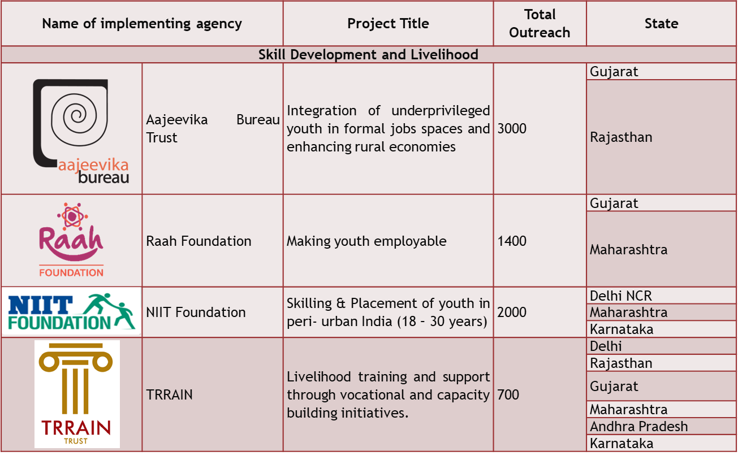

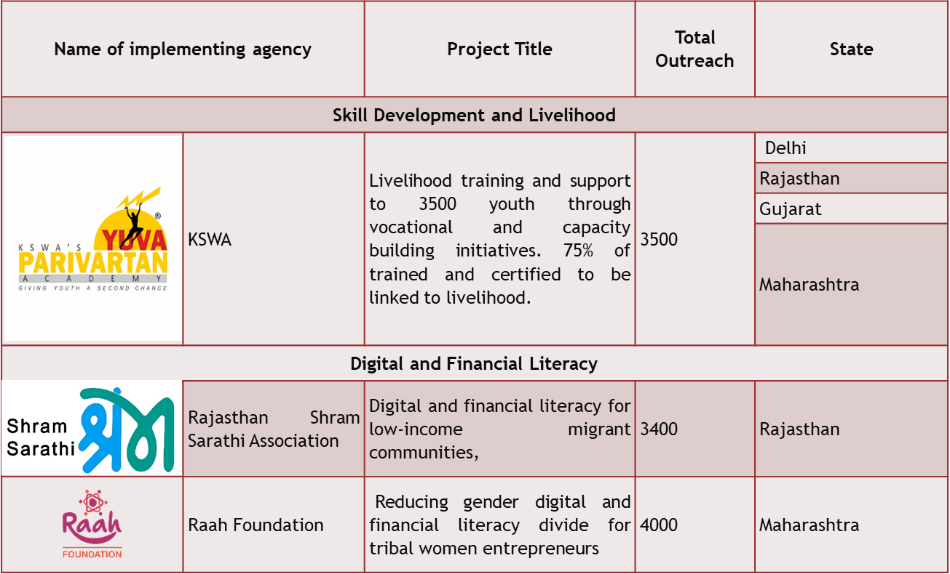

Given the objectives of the programme, Angel One is conducting an impact evaluation study for its projects and has commissioned TTC to conduct a third part impact evaluation study for the same. The scope of work has been detailed below:

* Desk review of project documents and other relevant literature to further the understanding of the projects.
* Development of impact evaluation framework and study instruments.
* Undertaking primary research in select project areas, comprising both quantitative and qualitative elements for baseline study.
* Development and finalization of the impact evaluation reports capturing the relevance of the projects, coherence with the government schemes, efficiency and effectiveness of the projects, their outputs and sustainability.
* Other deliverables for the project involve the inception report, survey tools and field plan.

# Approach

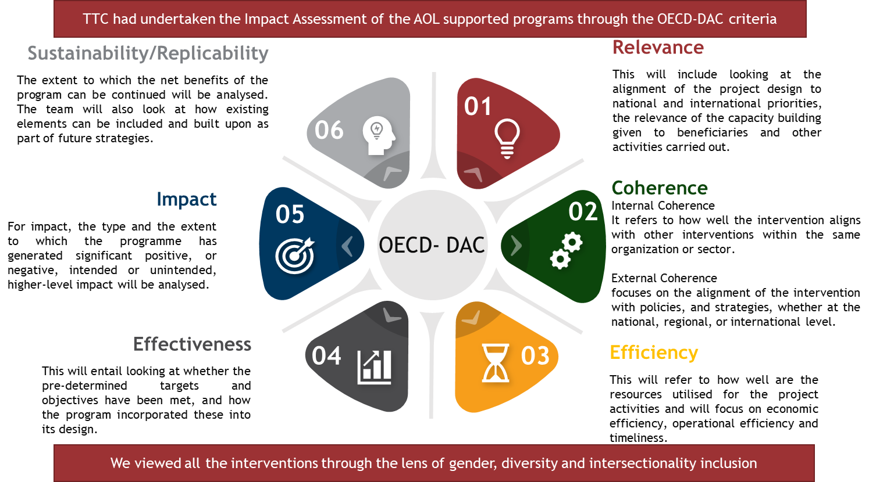

TTC followed the OECD- DAC approach for the study of assessing the enlisted projects under Angel One CSR programme. As per the scope of work, TTC conducted evaluation of each project under Angel One CSR programmes in Maharashtra, Gujarat, Karnataka and Rajasthan.

As per the DAC Criteria, TTC undertook a structured evaluation of each project to assess its relevance, effectiveness and efficiency in project planning, implementation, and monitoring as well as the socio-economic impact generated by the project through intended and unintended outcomes, sustainability and coherence. For project evaluation, TTC distinguished the enlisted projects into the following categories (categorized by thematic area).

| **Digital and Financial Literacy** | **Skill development and employability** |
| --- | --- |
| Projects aimed at enhancing digital and financial literacy and supporting tribal women and marginalised groups such as migrants are assessed using the OECD-DAC criteria to ensure alignment with national and state economic empowerment strategies. The relevance of these projects is determined by their alignment with goals promoting youth, women and migrant communities’ economic participation, while effectiveness is gauged through project planning, target achievement, and monitoring. Efficiency involves evaluating resource utilization against budget constraints and resource adequacy. The impact assessment focuses on the outcomes these initiatives have on women's and underprivileged youth digital and financial literacy. Sustainability examines the continuity of benefits, and coherence assesses the integration with other related initiatives, ensuring that efforts are synergistic and not duplicate, thus maximizing the impact on economic empowerment and gender equality. | Projects undertaken to upskill or improve technical education as well as employment linkages for youth and job seekers in target areas. For skill development projects, TTC will assess relevance by looking at how the projects address skill gaps and employment needs in the target areas. Effectiveness evaluation will cover project planning, resource deployment, achievement of skill development targets, quality assurance processes, monitoring mechanisms, and implementation challenges. Efficiency will involve reviewing resource utilization, financial review mechanisms, adequacy of human resources, and cost-effectiveness. The impact assessment will focus on the intended and unintended outcomes related to skill enhancement and employment generation. Sustainability analysis examines efforts to ensure the continuity of skill development outcomes and the sustainability of entrepreneurial ventures. Sustainability will examine efforts made to ensure the continuity of skill development outcomes. Coherence will look at how the projects align with other skill development initiatives and policies. Integrating entrepreneurship into skill development initiatives enhances economic self-reliance and fosters innovation among beneficiaries. |

The matrix below unpacks the evaluation questions as per the OECD-DAC framework along with proposed tools for data collection.

| **Evaluation Questions** | | **Data Collection Tool** |
| --- | --- | --- |
| **Relevance** | * What were reasons behind choosing to implement these projects? * How are the projects aligned with national and state government priorities in education, livelihood, and skill development? * Are the projects aligned with local and contextual needs of the beneficiaries? | Survey, in depth interviews, KIIs |
| **Effectiveness** | * How detailed are the MoAs? * Was the project supported by a well-defined and planned program framework? * How were the resources deployed and planned- HR, finance, operations, planning process, training, stakeholder, timelines? * Was the projects able to achieve targets set in MoAs? * What were the checkpoints under quality assurance mechanisms? * What were the actions that facilitated/inhibited the achievement of results? * What were the monitoring mechanisms for the projects and were they sufficient? * Accuracy and effectiveness of budgeting. * Identifying variances, if any. * Making informed decisions for future budgeting. * Substantiveness of expenditure i.e., supported by adequate supporting documents/invoices; and * Allowability of expenditure i.e., has been incurred as per the terms of the agreement signed with the donor/budget approved by the donor. * What were the on-ground challenges in implementing the project? What level of effort was made to overcome practical constraints challenges? Was there any mid-course correction? | In depth interviews, KII, and physical observation checklists |
| **Efficiency** | * Was evaluation of resources, service and delivery undertaken at regular intervals? * Was intake and deployment of Human Resources at each stage adequate? * Were resources from intervention areas involved in project planning implementation or monitoring? * Were the costs of the project justified by its results? | In depth interviews, KIIs |
| **Outcome/impact** | * Is there a visible change within the beneficiary community? * Have the intended impacts been met? * Has the project influenced any state or national level policies? * Were there any unintended impacts that came about due to the programme? * What are the changes in the perception, attitude, and behaviour of the beneficiary community after the completion of the project? | Surveys, in depth interviews, KII, FGD and case studies |
| **Sustainability** | * Does the programme align itself with any SDGs? * Were beneficiaries and communities oriented on the nature and intentions of these programs? * Has the programme been able to guide the community effectively? * What is the phase-out strategy devised for the project? What actors does it include at the state and local level? Were these actors included during the planning and implementation of the projects? * How has the project implementation been able to create sustained change in the economic/ social status of the community members? | Surveys, in depth interviews, KII, and case studies |
| **Coherence** | * Are the project’s outputs affordable and cost-effective for target beneficiaries? * What is the external coherence consistency and CSR policies? * What was the extension to which the interventions addressed the interlinkages with other similar interventions? | In depth interviews, KII, and case studies |

# Methodology

To successfully execute the engagement, TTC designed a robust methodology that was derived from our experience of undertaking similar assessments and was guided by the approach. The methodology consisted of three phases. These phases were further bifurcated into detailed and rigorous work steps that projects an in-depth and comprehensive account of all the functions that were carried out for the evaluation and impact assessment of all the seven projects. The three phases of the evaluation are as follows:

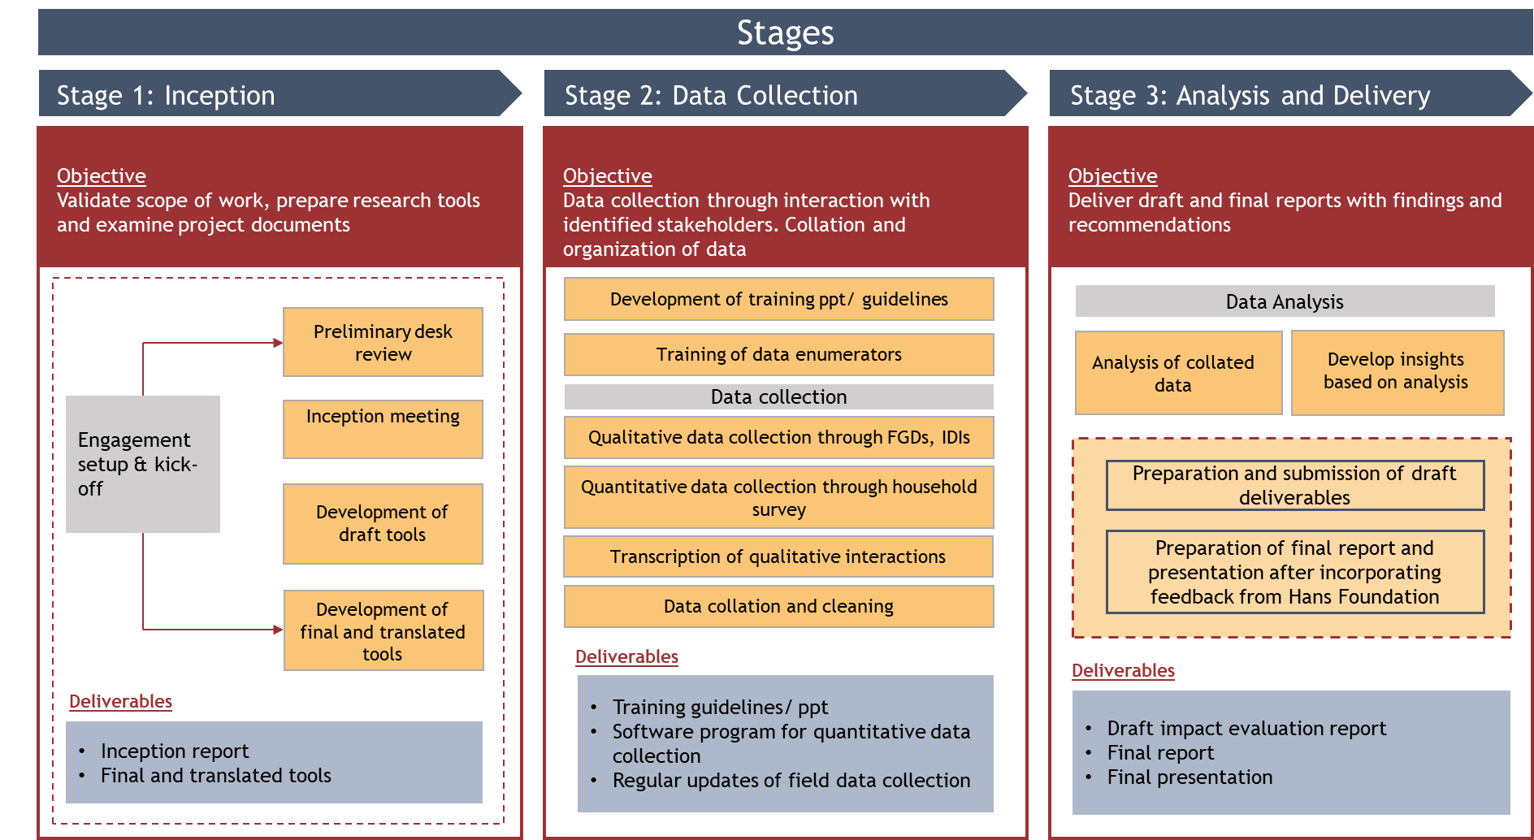

## Stage 1: Inception

* **Preliminary desk review**: During this phase of the assignment, TTC undertook an in-depth literature review of existing materials such as:
  + Angel One CSR strategy
  + Project mandates
  + Program documents including MoA/ MoUs with implementing partners
  + Monthly, quarterly and annual reports of each project
  + Project MIS
  + Baseline reports, if available

The available documents were segregated project wise under relevant themes to systematize the literature review process, which strengthened the study team preliminary understanding of all the seven projects supported by Angel One and provided a foundation for the findings to be validated and substantiated during the subsequent data collection phase. The information collected from the structured literature review was collated and organised in an analysis framework which aided in tool development.

* **Inception meeting**: An inception meeting was held in August 20024, where the TTC team and Angel One team arrived at a shared understanding vis-à-vis the scope of work and set clear expectations for the engagement. Angel One also aided in connecting TTC with the implementing partners for the projects. This provided an opportunity to interact with relevant stakeholders and implementing partners to develop a preliminary understanding of the program’s context that specifically caters to the demographic of selected intervention areas across seven projects. This meeting also helped in establishing the study strategy for each project and focus on geographies within project locations to establish inclusivity.

After this meeting, TTC conducted individual meetings with each of the implementing partners to better understand the context of each project.

* **Research Design**: The study followed a mixed methodology approach wherein both quantitative and qualitative tools were used along with physical observations. Quantitative data was collected through surveys with beneficiaries, while qualitative data was gathered using tools such as focus group discussions (FGDs), in-depth interviews (IDIs), and key informant interviews (KIIs). Quantitative data was leveraged to identify top-level trends, including the outcomes and impact of each project, while qualitative data was utilized to uncover and highlight the underlying causes of these trends.
* **Tools**: TTC developed a combination of qualitative and quantitative tools. These included in-depth interviews (IDIs), key informant interviews (KIIs), and focus group discussions (FGDs), along with quantitative surveys. Additionally, TTC designed formats for collecting change/impact stories, illustrating stakeholder transitions throughout the project life cycle. The categories of stakeholders and relevant tools for each category across the interventions, along with key probe areas, were presented as part of the Research Framework.
* **Sampling:** TTC finalized the sampling frame and sample for quantitative data collection. The sample locations for quantitative and qualitative sampling have been selected on the following parameters:
  + Districts with the maximum number of training centers and beneficiaries
  + All the courses provided by the implementing partners
  + Both urban and rural centers

Using the purposive random sampling method, the respondents will be selected at random according to the availability in their position. Research team will try to ensure non-discrimination and inclusion of all gender, class and ability.

Quantitative Sampling Strategy:

Cochran’s formula was utilized for quantitative sampling of each project. The formula is detailed below:

n = N*X / (X + N – 1), where, X = Zα/22 ¬*p*(1-p) / MOE2 and Zα/2 is the critical value of the Normal distribution at α/2.

TTC ensured that the sample followed a confidence interval of 95% with a 5% margin of error and accounted for 8-10% non-responses. Efforts were made to cover a statistically representative sample, with at least 50% representation where the universe was less than 100 for all interventions, ensuring coverage across the maximum number of locations.

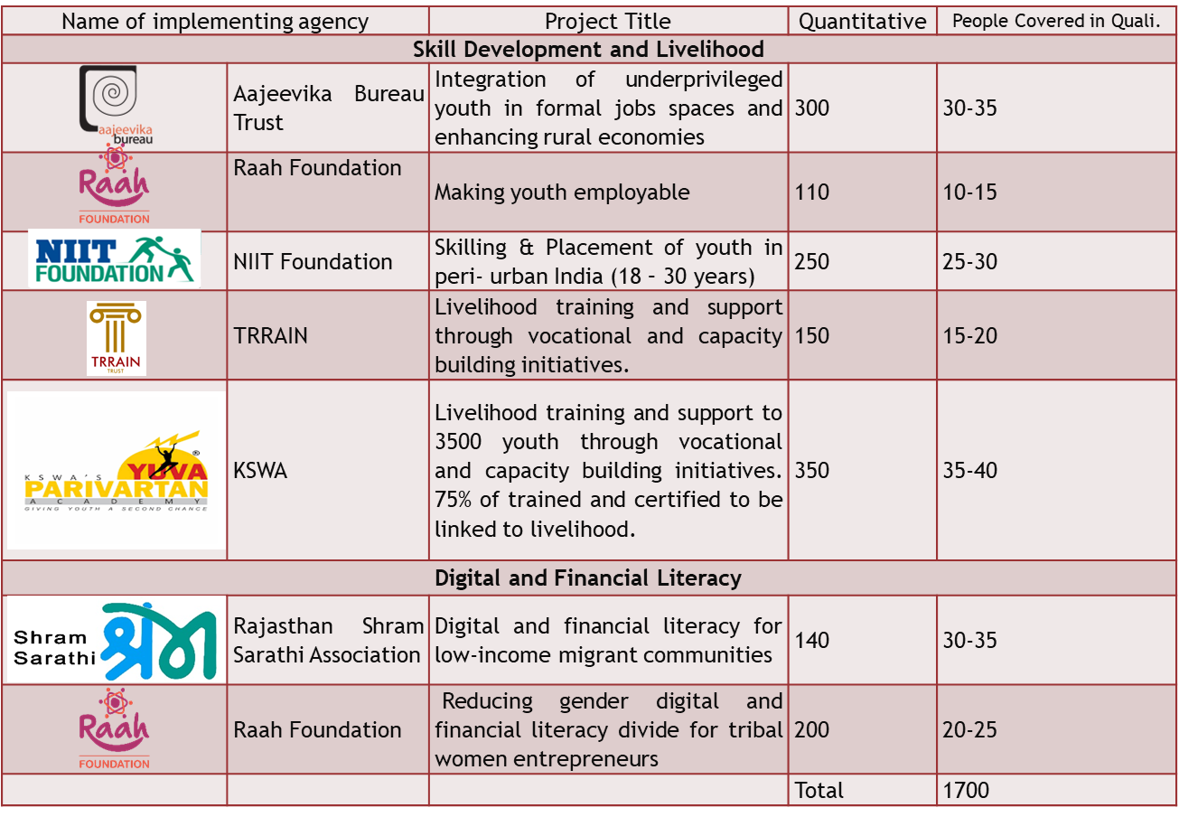

## Stage 2: Data Collection

**Field Team and Training:** Prior to data collection, the study team was adequately trained on intervention objectives, methodology, study tools, sampling, and ethical considerations. The training encompassed both theoretical and mock sessions to ensure that the team was well-versed with the tools and the local and contextual nuances.

**Field Planning:** A detailed field movement plan, outlining day-wise locations and primary sampling units, was shared along with this report. After incorporating feedback from Angel One, the field data collection proceeded as per this plan.

**Qualitative Data Collection:** The TTC team visiting the field for qualitative data collection included women with prior experience in various thematic areas and an understanding of gender dynamics and needs. TTC ensured that all interactions with the target group were conducted by field researchers familiar with the region, its dialect, the program, and the context. The qualitative team was led by a senior professional from TTC with extensive experience in conducting qualitative research on the ground. They ensured the participation of all respondents and captured diverse perspectives using carefully designed tools. The key facilitator was supported by another team member responsible for taking notes and acting as a gatekeeper to manage any unsocial or disruptive elements.

**Quantitative Data Collection:** Sufficient quality checks, including skip logic and validations, were programmed into the survey to ensure the highest quality of data collected. The data entered by respondents was reviewed at the end of each day, and a response sheet was generated, highlighting any detected anomalies. The research coordinator coordinated with the data collection agency’s POCs to resolve glitches and conduct re-surveys wherever necessary. Coding of responses was undertaken in advance to facilitate a smooth and organized data analysis process. To maintain data integrity, TTC conducted spot checks and back checks in the field, ensuring data quality and sanctity throughout the entire data collection process.

## Stage 3: Analysis and Delivery

**Data Cleaning and Validation:** All data was cleaned and validated to remove any errors and inconsistencies. Wherever gaps emerged in the data, the research team reached out to relevant stakeholders telephonically to fill those gaps. The datasets were then coded, and dedicated processes were adopted for both quantitative and qualitative data analyses.

**Quantitative Data Analysis:** The first step in quantitative data analysis was to clean and organize the data. Once prepared, the dataset was analyzed using statistical software, including Excel and SPSS, to generate results. The preparation of these results was carried out through the lens of the study framework, ensuring that the data analysis team had a clear plan and hypothesis during analysis. This approach facilitated the synthesis of both forms of data, leading to more robust results. The quantitative data was analyzed using a correlational approach to understand and explain observations. The research team also applied parametric tests. Information received from each source was explored, internal databases were created, and the data was correlated, analyzed, and cross-tabulated to provide holistic results. At the end of the data cleaning and tabulation process, TTC developed a chapter plan. The analysis was guided by the approach deployed for conducting the research. The data collected through various tools, once cleaned and collated, was organized under different components as depicted in the approach.

**Qualitative Data Analysis:** The primary results from the field were collated and organized, and team members triangulated perspectives presented by various stakeholders to develop holistic insights on key research questions. The process was guided by the analysis framework developed during the inception stage, where all field-level insights and findings were collated and transcribed. Once organized, the qualitative data was analyzed using content analysis through Atlas Ti. A code-sheet was developed based on key indicators and concepts identified in the RFP and during the inception phase. This was followed by systematic coding or labeling of interview transcripts to retrieve the identified themes and concepts. This process allowed the team to build a coherent narrative around the study area.

**Triangulation of Data:** Based on the collected information, "finding statements" for each research question were drafted. The qualitative and quantitative data were merged to qualify, prove, and explain the observed trends. A detailed draft report was prepared for each project and submitted to Angel One for review.

## Report Structure

|  |  |
| --- | --- |
| S.No. | Chapter |
| 1 | Executive Summary |
| 2 | Background   1. Purpose, objective and scope of work 2. Project Overview 3. Project context 4. Outreach, partners, stakeholders and other project details 5. Approach and Methodology 6. Limitations of the assessment |
| 3 | Key Findings   1. Relevance    1. Project design & implemented to meet the need of all the targeted groups and were relevant to state, national and global priorities    2. Contextual factors were analyzed while designing and implementing the project 2. Coherence    1. How well does the intervention align with Angel One’s overall CSR strategy and objectives?    2. To what extent does the intervention coordinate with other NGOs, government agencies, and community-based organizations working in the same area?    3. How does the intervention complement or enhance existing services and programs in the target areas? 3. Efficiency    1. Financial review of project in terms of deployment of funds for achieving adequate outcomes    2. Project implementation is aligned to the time frame and optimum utilization of disbursed funds 4. Effectiveness    1. The project had a comprehensive outreach mechanism    2. The project identified and addressed the problem of the targeted beneficiaries    3. The management structure helped the project to be more effective 5. Impact    1. Observed measurable changes    2. Project identified potential challenges and opportunities    3. Other unintended outcomes were observed 6. Sustainability    1. Enhanced participation for both direct & indirect beneficiaries for project continuity    2. Active support and engagement of all key stakeholders across value chain    3. Measures incorporated to ensure community ownership during implementation and post- project    4. Mechanism for collaboration with government departments developed to ensure project replicability |
| 4 | Conclusion and Recommendations |
| 5 | Annexures   1. Terms of Reference 2. Evaluation framework 3. Sampling plan 4. Literature review log 5. Field plan and stakeholder list 6. Data collection tools 7. Analysis framework |

TTC duly incorporated the feedback received from Angel One and presented a final copy-edited report at the end of the assignment term, along with a presentation of the key findings.

## Quality Assurance

Quality assurance steps were taken at each stage of the study to ensure that high-quality data was generated and processed.

* Throughout the process, it was ensured that the collected data was reliable and valid. TTC implemented a three-level monitoring structure for this study, deploying quality check mechanisms at three stages: input, collation, and validation. Quality checks were placed over all key activities of the project, including recruitment, field training, data collection, team movement, and data compilation.
* Only experienced and trained researchers were involved in data collection to ensure quality. Additionally, all team members involved in data collection were oriented toward the tools used in the study.
* An internal control mechanism was set up using a live dashboard, which was shared with Angel One. This allowed both Angel One and TTC to track progress in alignment with the project timeline.

# Aajeevika Bureau Trust - Integration of Aspiring Youths in Formal Job Spaces

This executive summary provides an overview impact assessment finding for the skill training and employability program implemented by Aajeevika Bureau Trust with support from Angel One CSR. The initiative focuses on empowering underserved communities across Rajasthan and Gujarat. TTC was appointed to conduct a third part impact assessment which adheres to the OECD-DAC framework, evaluating the program's relevance, effectiveness, efficiency, outcomes, impact, and sustainability. Employing a robust mixed-methods approach, the study integrates quantitative and qualitative data from diverse stakeholders to present a holistic evaluation of the program's achievements and areas for improvement.

## Background and Context

Skill development is a crucial component of economic growth, workforce preparedness, and poverty alleviation. In India, where a significant proportion of the population is under 30 years old, effective skill training initiatives can directly impact employment rates and economic sustainability. However, challenges such as a lack of market-aligned skills, limited access to formal training, and socio-economic barriers have created a skills mismatch in the job market.

The "Integration of Aspiring Youths in Formal Job Spaces" program was developed as a response to these challenges, aiming to empower youth from low-income households in Rajasthan and Gujarat through skill training, formal employment placements, and self-enterprise opportunities. Supported by Angel One CSR and implemented by Aajeevika Bureau Trust, the initiative aligns with national priorities such as the Skill India Mission, which seeks to enhance employability and promote sustainable livelihoods through skill-based interventions.

## About the Program

The program was conceptualized to provide skill development training and employment opportunities for marginalized youth in selected districts of Rajasthan and Gujarat. The target regions were selected based on factors such as high unemployment rates, marginalized tribal populations, and limited access to vocational training programs. In Rajasthan, the program was rolled out in Udaipur, Dungarpur, Banswara, Chittorgarh, Jodhpur, Bhilwara, Pratapgarh, Rajsamand, and Sawai Madhopur. These districts face significant skill gaps due to the dominance of informal labor markets and a lack of industry-aligned vocational education. In Gujarat, the program was primarily implemented in Ahmedabad, a key industrial and commercial hub. While Gujarat has a strong economy, many youths from rural and semi-urban backgrounds lack the skills needed to access formal employment. The choice of these locations was informed by market research and labor demand analyses to ensure alignment with economic opportunities in these regions.

The primary objectives of the program included:

* Mobilizing and counseling 6000 youth from underprivileged backgrounds.
* Providing skill training to 3000 youth to improve their employability.
* Ensuring an ecosystem where youth are equipped with skills and knowledge required by industries
* Enhancing the employability of youth to adjust in formal job market
* Creating a platform for youth as well as employers to bridge employment gaps
* Ensuring placements of youths into formal setting after training
* Ensure retention of youth after their placements and support needed
* Extend post-training support and for easy entry in markets and retain the skills gained

To meet these objectives, the program was structured into three key training pathways:

Formal Sector Employment Training – Focused on preparing youth for corporate and industry-based jobs in sectors such as retail, IT, and hospitality. Self-Enterprise-Based Training – A component of the formal sector employment training, it was designed for youth who aspired to start their businesses in trades like tailoring, mobile repair, and electrical work. Placement Readiness Training – A preparatory program to equip candidates with interview skills, communication techniques, and workplace etiquette.

The program cycle comprised Mobilisation, Training Delivery, and Placement. Mobilisation involved community outreach through Yuva Melas, counseling, and batch formation based on course preferences. Training was conducted through residential (30-day) and non-residential (45-day) models, covering technical, soft, and life skills. The Placement phase provided job preparation, employer connections, and post-placement support, including accommodation for placed candidates and toolkits for self-employed individuals.

## Study Objectives and Methodology

To assess the impact and effectiveness of the program, a comprehensive study was conducted by TTC using a mixed-methods approach that combined qualitative and quantitative research. The methodology was designed to measure relevance, efficiency, effectiveness, impact, and sustainability using the OECD-DAC evaluation criteria.

1. Quantitative Data Collection – A structured survey was conducted among 301 respondents, including youth who had completed training. Data was gathered on training effectiveness, employment status, income changes, and training delivery and job satisfaction.
2. Qualitative Data Collection – Focus Group Discussions (FGDs), Key Informant Interviews (KIIs), and in-depth case studies were conducted with trainees, trainers, employers, and program stakeholders to capture diverse perspectives.
3. Secondary Research – A review of policy documents, program reports, and program MoUs was undertaken to contextualize findings within the broader skill development landscape.
4. Monitoring and Evaluation – Data was triangulated to ensure accuracy and validate findings.

The study used a purposive sampling approach to ensure representation from different training centers, districts, and training categories. The sample was drawn at a confidence interval of 90% with 5% margin for error and 8-10% non-responses using Cochren’s Formula with ensuring representation of maximum number of locations. A total of 3,280 students were trained by Aajeevika Bureau Trust, and the sample size initially determined was 252. However, to ensure greater representation across a wider range of locations, a larger sample size of 301 students spread equally across the three districts of Udaipur, Rajsamand and Ahmedabad was selected.

Though the study framework was designed in a manner to ensure high quality deliverables with mandatory measures for foreseeable risk mitigation in place, the study was constrained by some limitation. The insights presented in this study report are based on data/information provided by the various stakeholders. To the best of its ability, the research team has tried to ensure and validate the authenticity of data/information submitted by the respondents. However, it would be fair to assume certain errors in data recording.

## Key Findings

 The key findings for this impact assessment study are structured in line with the OECD-DAC criteria. Observations, insights and findings are presented according to relevance, effectiveness, efficiency, outcomes/impact and sustainability.

The quantitative survey covered 301 respondents, primarily young individuals (88% under 25) from marginalized backgrounds in need of employment. The gender distribution was nearly equal (52% men, 48% women), though initial challenges in enrolling women were addressed through community counseling. The program promoted inclusivity by integrating four candidates with locomotor disabilities. Most respondents (66%) belonged to OBC, SC, and ST communities, and 84% had an annual family income below INR 1,00,000, aligning with the program’s focus on economically disadvantaged groups. The majority were unmarried youth in early career stages. Women preferred formal employment training, while men leaned towards self-employment courses, influenced by social norms. The most popular courses were Tally (41%) and Retail & Sales (35%), followed by Business Development Executive, GDA, and AC/DC Motor Winding.

|  |  |  |
| --- | --- | --- |
| S.No | OECD-DAC Criteria | Findings and Observations |
|  | Relevance | The program aligned well with the employment needs of the target communities, addressing skill shortages in high-demand sectors such as **retail, sales, and IT.**  **96% of trainees found the course useful** for career advancement, with a high retention rate in the workforce.  **Women’s participation increased significantly** due to targeted outreach, though cultural barriers remained a challenge in some areas. |
|  | Coherence | The program was **coherent with India's Skill India Mission (SIM)** and aligned with government schemes like PMKVY, JSS, and NAPS. It addressed skill gaps in Rajasthan and Gujarat, where unemployment and informal sector employment are prevalent, by offering industry-relevant training in Retail & Sales and IT.  The program closely **matched Angel One Limited CSR’s focus** on youth empowerment through skill development. It supported marginalized communities by bridging the gap between education and employment, fostering sustainable livelihoods, and promoting economic self-reliance. |
|  | Effectiveness | The program exceeded its outreach targets, **mobilizing 6,014 youth and training 3,280 participants.**  More than 70% of formal sector trainees secured jobs with **an average salary of INR 12,592 per month.**  The data driven approach enabled **efficient tracking of the student progress** and facilitated quick access to real time information for decision-making.  **Attendance of the trainees was monitored rigorously**, with measures like parental permissions for absences and follow-ups for prolonged absenteeism. These measures ensured regularity of the students.  The initiative facilitated meaningful interaction between youth and employers through **pre-placement support, industrial visits, and industry workshops**. These efforts not only provided students with practical insights into work environments and job roles but also nurtured networking opportunities.  Post-placement supports aided students to adapt to their new work environment, address challenges and build confidence, thereby increasing the job retention rates. |
|  | Efficiency | The use of "**Yuva Mitras**" for community mobilization increased awareness and ensured high enrolment rates.  A **digital Monitoring & Evaluation (M&E) system** improved data collection, enabling better program tracking and decision-making.  **Financial resources were optimally allocated**, ensuring training was accessible to students from low-income households. |
|  | Outcomes and Impact | 49% of respondents indicated that the training had **enhanced their skills and confidence**, while 46% mentioned it **opened new opportunities for them**.  The average monthly income of the candidates increased **from INR 522 to INR 9423**.  There was a marked increase in **self-confidence, communication skills, and financial independence** among participants.  Women trainees, despite facing societal constraints, reported **improved career aspirations and financial autonomy.** |
|  | Sustainability | **Post-placement support, mentorship, and alumni networks** helped trainees sustain their employment.  Employer partnerships provided a steady pipeline for **job placements.**  Continuous curriculum updates ensured training programs remained aligned with industry trends. |

## A black background with a black square Description automatically generated with medium confidenceRecommendations

Triangulating on the feedback collected from the students, trainers, employers and parents/community, the study recommends the following**:**

* **Institutionalizing orientation sessions**: To ensure smoother integration and foster collaboration, it is recommended to institutionalize structured orientation sessions as part of the program.
* **Standardizing training processes**: To improve the program’s quality and ensure uniformity in operations, it is recommended to develop a standardized ToT program along with detailed SOPs. This would ensure consistent practices, improve training outcomes, and support trainers in delivering the program’s intended impact effectively.
* **Extending Course Duration and Curriculum Expansion:** It is suggested that the course duration be extended by five to ten days to cover foundational topics such as savings and financial literacy. This addition will provide students with practical knowledge and skills to enhance their financial independence and increase their chances of success in self-employment ventures.
* **Focus on Enhancing English Proficiency:** It is recommended that the English curriculum be enhanced with interactive speaking exercises, culturally neutral vocabulary building, and accent training. These adjustments will help students improve their communication proficiency, build their confidence, and foster better workplace integration.
* **Implementing Psychometric Assessments:** To better understand the aspirations, interests, and aptitudes of the youth, it is recommended to implement psychometric assessments.
* **Parental Consent and Increased Involvement:** For students enrolled in the residential model, it is crucial to obtain written consent from their parents or guardians. This ensures that families are informed and supportive of the students’ participation in the program, particularly in residential areas. In addition to obtaining consent, it is recommended to enhance parental involvement through regular meetings and updates.

## Conclusion

The "Integration of Aspiring Youths in Formal Job Spaces" program has demonstrated a significant positive impact on youth employment and skill development in Rajasthan and Gujarat. By addressing skill gaps, providing targeted training, and fostering industry connections, the initiative has helped participants transition from informal labor to structured employment and entrepreneurship. Moving forward, refining program strategies and expanding reach will enhance long-term sustainability and create a more inclusive workforce. The lessons learned from this program offer valuable insights for scaling similar skill development programs in India and beyond.

# Raah Foundation - SAMARTH Employment Guarantee Program and the Digital Journalism Course

India stands at a crucial juncture, with a youthful workforce comprising 62% of its population in the working-age group and 54% under 25 years of age. Harnessing this demographic dividend requires concerted efforts in skill development, employment generation, and economic inclusion. Against this backdrop, Angel One Limited, in collaboration with Raah Foundation, has launched targeted initiatives such as the **SAMARTH Employment Guarantee Program** and the **Digital Journalism Course** to bridge skill gaps and enhance employment opportunities for marginalized communities. This executive summary presents key insights from the impact assessment conducted by TTC, evaluating the effectiveness, relevance, coherence, efficiency, and sustainability of these interventions.

## Background

India’s demographic dividend presents an unprecedented opportunity for economic growth, but structural challenges in skill training and employment continue to hinder progress. While the country’s economy is growing rapidly, a significant portion of its workforce remains unskilled or inadequately trained to meet industry demands. According to the **Periodic Labour Force Survey (PLFS) 2020-21**, only **4.7% of India’s workforce has received formal vocational training**, starkly contrasting with 52% in the U.S., 80% in Japan, and 96% in South Korea.

The skill gap is particularly pronounced among **youth and women**, who face **higher unemployment rates despite educational attainment**. In urban areas, youth unemployment stood at **17.2% in 2022**, indicating a mismatch between education and labour market requirements. Women experience even greater disparities, with their unemployment rates **50% higher than men’s**, driven by **limited access to vocational training and workplace readiness programs**.

The **SAMARTH and Digital Journalism programs** directly address these gaps by equipping youth with **industry-relevant skills, workplace competencies, and career-oriented training**, ensuring employability and economic security. These programs are particularly relevant for India’s **emerging digital economy**, where **IT services, retail, BFSI, and digital media are witnessing exponential growth**. By bridging skill gaps and fostering sustainable employment pathways, these initiatives contribute significantly to **India’s development goals, financial inclusion, and gender empowerment**.

## About the Program

The skill training and employability program (i.e., SAMARTH Program and Digital Journalism), is designed to enhance the employability of youth aged 18-25 by equipping them with both technical and soft skills. The program is strategically implemented across the various locations of Maharashtra and Gujarat including Mumbai, Pune, Nashik, Latur, Vadodara and others, ensuring outreach in both urban and semi-urban settings. These locations were selected based on **high youth unemployment rates, demand for skilled professionals, and accessibility of training centres**.

A detailed program overview is given below:

* The **SAMARTH Employment Guarantee Program** is designed to equip underprivileged youth with job-oriented skills in sectors such as **retail, IT-enabled services, and BFSI**. The **35-day intensive training program** covers essential workplace skills, including **English communication, sales & marketing, financial literacy, and IT tools (Tally, GST, MS Office)**. The program ensures structured job placements for successful candidates, helping them transition smoothly into formal employment
* The **Digital Journalism Course** is a **six-month blended learning initiative** aimed at preparing youth for careers in **digital media, fact-checking, multimedia storytelling, and social media-based reporting**. The curriculum combines **theoretical instruction, field assignments, and internships** to ensure practical learning. The course is accredited by the **Maharashtra State Board for Vocational Training**, enhancing its credibility and industry recognition

## Study Objectives and Methodology

The impact assessment study was conducted in three phases: Delve, Diagnose, and Deliver. The study utilized a mixed-methods approach, combining quantitative and qualitative data collection methods to capture diverse stakeholder perspectives. The evaluation framework was aligned with the OECD-DAC criteria, focusing on:

* **Relevance:** To determine the program's alignment with the needs of the target communities and the demands of the job market.
* **Coherence:** To evaluate the internal consistency of the program's design and implementation.
* **Effectiveness:** To measure the extent to which the program achieves its intended objectives.
* **Efficiency:** To assess the program's resource utilization and cost-effectiveness.
* **Outcomes & Impact:** To analyze the changes resulting from the program, including job placements, income enhancement, and overall well-being improvements.
* **Sustainability:** To evaluate the long-term viability and potential for continued positive impact

Data collection involved surveys, focus group discussions, and key informant interviews with various stakeholders, including students, trainers, employers, and community members. The sampling strategy ensured geographical representation and diversity of beneficiaries. Using Cochran's formula, **stratified** **random sampling was adopted for beneficiary selection**. **A confidence interval of 95% with a 5% margin of error and 8-10% non-responses was ensured while choosing the sample size**. Thus, a total sample of 109 was selected and overall, 109 respondents were covered

Though the study framework was designed in a manner to ensure high-quality deliverables with mandatory measures for foreseeable risk mitigation in place, the study was constrained by the limitations. Firstly, availability of students due to demanding working hours and busy festive season were offset by virtual and telephonic interactions. Secondly, the study's insights are based on stakeholder-provided data. While the research team has sought to validate its authenticity, some recording errors may exist. Thirdly, the trainers for Digital Journalism were located out of station, thus interactions with the trainers were hosted virtually based on their availability.

## Key Findings

**Respondent Profile**

* The program predominantly **attracted youth aged 18-22**, 58% of the respondents were women, reflecting the program’s commitment to gender inclusion.
* Approximately **89% of respondents belonged to households with an annual income below INR 2 lakhs**, emphasizing the program’s targeted outreach to economically disadvantaged groups.
* Prior to enrolment, **52% were students, 23% were unemployed** seeking better opportunities, thus, the program reached out to youth who aspired to improve their skills and those who desired career progression.

The findings are structured in line with the OECD-DAC criteria and are presented in the matrix below:

|  |  |  |
| --- | --- | --- |
| S.No | OECD-DAC Criteria | Findings and Observations |
|  | **Relevance** | * The program strategically aligns with national skill development priorities and **addresses local community needs.** The SAMARTH and Digital Journalism programs effectively addressed employment challenges in Maharashtra and Gujarat by **equipping marginalized youth with industry-relevant skills.** * **95% of beneficiaries affirmed the program’s direct relevance** **to their career goals**, underscoring its effectiveness in bridging skill gaps and enhancing employability. * The program **prioritized first-generation learners** and financially underprivileged families, **fostering regional talent retention and development in Tier-2 and -3 cities** and reducing migration. * The project locations identified under the program despite being an economic hub, lack of technical skills and job readiness among underserved communities hinders employment integration, especially in BFSI, IT, and retail sectors. This holistic approach drives skill development and economic empowerment advancing **SDG 1: No Poverty, SDG 4: Quality Education, SDG 8: Decent Work and Economic Growth, and SDG 10: Reduced Inequalities.** |
|  | **Coherence** | * The program **aligns strongly with Angel One’s mission** to enhance employability and promote sustainable livelihoods. * Furthermore, the program **aligns externally** with national skill development initiatives such as **Pradhan Mantri Kaushal Vikas Yojana (PMKVY)**, reinforcing its contribution to broader socioeconomic goals. |
|  | **Effectiveness** | * **Raah Foundation adopts a Holistic and Inclusive Framework** withstudents as catalysts for social change, supported by an enabling environment that foster continuous learning, unlearning, and holistic development. **With a wide range of stakeholders, the Skill Training Program fostered a collaborative and participative approach.** * The program's partnership with organizations like **Unnati Foundation and SwayamTej Foundation** enhances **transparency and efficiency** in the **training process**, with a particular focus on **curriculum development and assessment standards.** * A **multi-pronged strategy** was employed, encompassing mobilization, counseling, training, placement, and post-placement support. Beneficiaries, primarily 12th-pass or graduate-level individuals from underserved communities, were identified through a **rigorous selection process to minimize inclusion and exclusion errors.** * **72% of students enrolled in SAMARTH, while 28% pursued Digital Journalism.** The most used instruction medium was English (54%), followed by Hindi (24%) and regional languages (22%)**. The flexibility in the medium of instructions ensured inclusivity of respondents from the underserved community.** * The Raah Foundation provided structured placement support, including interview preparation, resume writing, and career counseling. **85% of students were satisfied with pre-placement assistance**. * Student progress was tracked through the SIXER CLASS application and a Learning Management System (LMS), with **external monitoring by Unnati Foundation to ensure program quality**. |
|  | **Efficiency** | * The **program efficiently utilized resources, ensuring high retention and minimal dropouts** through a dedicated mobilization team and multiple counselling sessions conducted in collaboration with Unnati Foundation in SAMARTH program. * The **SAMARTH program** exceeded its target, training 904 students against a target of 900, while the **Digital Journalism** course **met its target** of 200 |
|  | **Outcomes and Impact** | * The program demonstrated significant impact, with **41% of respondents securing employment** and **64% either successfully placed or opting out**. * Graduates reported enhanced skills, confidence, and social mobility, with many serving as community role models. **28% of respondents reported improvement in income through Raah’s placement**. * **On an average, beneficiaries received job offers starting at Rs. 10,000 in tier-2 cities and Rs.15,000 in Tier-1 cities**. * Employers recognized Raah Foundation students for their professionalism and workplace readiness. |
|  | **Sustainability** | * The program ensures sustainability through industry-recognized certifications, community mobilization, and mentorship. * **95% of students would recommend the course**, reinforcing its impact. |

## Recommendations

Triangulating on the feedback collected from the students, trainers, employers and parents/community, the study recommends the following:

**Restructure the SAMARTH Program:** Extending the course duration to 40-45 days with reduced daily hours would allow for a more comprehensive coverage of essential topics while enhancing focus on personality development. This adjustment could improve learning retention, engagement, and overall student development.

**Review Eligibility and Certification for Digital Journalism Courses:** Expand the eligibility criteria to include working professionals and implement a provisional certification system to address delays in official certification from the Maharashtra State Vocational Training Board**.**

**Enhance Community and Parental Engagement:** Conducting "A Day in the Community" sessions to engage parents and communities (the stakeholders who shape the career trajectory of the students) with the course and training activities can aid in improving the learning outcomes of the respondents.

## Conclusion

Raah Foundation's skill training initiatives have proven to be highly effective in empowering individuals from marginalized communities by providing them with valuable skills and increasing their employability. The SAMARTH and Digital Journalism programs have made a significant impact by equipping beneficiaries with practical skills, boosting their confidence, and enhancing their economic stability. By addressing the identified areas for improvement and by consistently incorporating feedback from diverse stakeholders, Raah Foundation can continue its role as a catalyst for empowerment and long-term community impact.

# NIIT Foundation - Change Maker Student Program

This executive summary provides an overview of impact assessment findings of the skill training and employability program implemented by NIIT Foundation with support from Angel One CSR. The initiative focuses on empowering underserved communities across Delhi-NCR, Maharashtra, Karnataka, and Gujarat. Conducted by an independent third party, TTC, the assessment adheres to the OECD-DAC framework, evaluating the program's relevance, effectiveness, efficiency, outcomes, impact, and sustainability. Employing a robust mixed-methods approach, the study integrates quantitative and qualitative data from diverse stakeholders to present a holistic evaluation of the program's achievements and areas for improvement.

## Background and Context

Education and skill development are fundamental drivers of socioeconomic growth, equipping individuals with the necessary capabilities to actively contribute to development and make informed decisions. However, global economic trends, including declining birth rates, an aging workforce, and rapid technological advancements, have led to significant skill mismatches. **Emerging economies such as India face pronounced underqualification due to limited access to education and vocational training, particularly among marginalized and underserved communities**.

India’s demographic potential presents a unique growth opportunity, with the country poised to have the world’s largest working-age population by 2030. However, this potential is hindered by regional disparities, high youth unemployment rates due to skill mismatches, and a predominantly informal workforce. Despite national initiatives such as the Skill India Mission and Pradhan Mantri Kaushal Vikas Yojana (PMKVY), only a small fraction of the workforce has received formal training. **Gender disparities further exacerbate these challenges, highlighting the need for targeted interventions to enhance female labour force participation** through education, skill development, and empowerment initiatives. **Recognizing these gaps, Angel One CSR launched the Skill Training and Employment Guarantee Program, targeting underserved communities in urban and peri-urban areas**. NIIT Foundation was selected as the implementing partner, leveraging its extensive expertise in establishing skill development centres and providing training and placement support for marginalized youth.

## About the Program

The Skill Training and Employability Program, also known as the Change Maker Student Program (CMS), is **designed to enhance the employability of youth aged 18-25** by equipping them with both technical and soft skills. The program is strategically implemented in states with robust service sectors, including Maharashtra, Karnataka, Delhi-NCR, and Gujarat. The **curriculum focuses on high-demand skills** relevant to the Business Process Outsourcing (BPO) and Banking, Financial Services, and Insurance (BFSI) sectors—two of India's fastest-growing industries.

The program employs a blended learning approach, combining in-person and virtual training sessions to enhance accessibility. Its primary objectives include:

* **Enhancing employability:** Equipping youth with skills aligned with evolving market demands.
* **Facilitating access to formal employment:** Creating pathways for marginalized youth to enter the formal job market.
* **Promoting holistic development:** Fostering personality development and leadership skills.
* **Ensuring inclusivity:** Expanding access to training for remote and low-income groups through virtual sessions.

## Study Objectives and Methodology

The impact assessment was conducted in three phases: Delve, Diagnose, and Deliver. A mixed-methods approach was used, incorporating quantitative and qualitative data collection methods to capture diverse stakeholder perspectives. The evaluation framework was structured around the OECD-DAC criteria, focusing on:

* **Relevance:** Assessing the program’s alignment with the needs of target communities and job market demands.
* **Coherence:** Evaluating the internal consistency of program design and implementation.
* **Effectiveness:** Measuring the extent to which program objectives were achieved.
* **Efficiency:** Analysing resource utilization and cost-effectiveness.
* **Outcomes and Impact:** Examining job placements, income enhancements, and overall well-being improvements.
* **Sustainability:** Assessing the long-term viability of the program and its continued positive impact.

Data collection involved surveys, focus group discussions, and key informant interviews with various stakeholders, including students, trainers, employers, and community members. The sampling strategy ensured geographical representation and diversity of beneficiaries. Using Cochran's formula, **stratified** **random sampling was adopted for beneficiary selection**. **A confidence interval of 95% with a 5% margin of error and 8-10% non-responses was ensured while choosing the sample size**. Thus, a total sample of 250 was selected and overall, 251 respondents were covered.

Though the study framework was designed in a manner to ensure high-quality deliverables with mandatory measures for foreseeable risk mitigation in place, the study was constrained by the limitations. Firstly, availability of students due to demanding working hours and busy festive season were offset by virtual and telephonic interactions. Secondly, the study's insights are based on stakeholder-provided data. While the research team has sought to validate its authenticity, some recording errors may exist.

## Key Findings

**Respondent Profile**

* The program predominantly **attracted youth aged 18-22**, with balanced gender representation in Delhi and a predominantly female cohort in Mumbai. The program primarily targets underserved communities with annual household incomes below two lakhs.
* Approximately **89% of respondents belonged to households with an annual income below INR 2 lakhs**, emphasizing the program’s targeted outreach to economically disadvantaged groups. A detailed analysis of the intersection between caste and class reveals that 57% of respondents belong to the general category.

The findings are structured in line with the OECD-DAC criteria:

|  |  |  |
| --- | --- | --- |
| **S.No** | **OECD-DAC Criteria** | **Findings and Observations** |
|  | **Relevance** | * The program strategically aligns with national skill development priorities and **addresses local community needs** by focusing on high-demand sectors such as BPO and BFSI. Its **flexible virtual training** model is particularly beneficial for women balancing education and domestic responsibilities. Targeting recent school graduates with aspirations for higher education or professional courses, the program **addresses financial barriers while enhancing confidence and spoken English skills** through classroom activities. * **Selection favours economically disadvantaged students**, excluding government employee households and those earning over INR 200,000. It bridges digital skill gaps, empowering marginalized youth for employment. NIIT’s collaboration ensures career guidance, securing opportunities in high-growth sectors. This holistic approach drives skill development and economic empowerment advancing **SDG 1: No Poverty, SDG 4: Quality Education, SDG 8: Decent Work and Economic Growth, and SDG 10: Reduced Inequalities.** |
|  | **Coherence** | * The program aligns strongly with Angel One’s mission to enhance employability and promote sustainable livelihoods. The NIIT Foundation’s **training model is preferred by the respondents over similar initiatives** by other NGOs and private organizations **due to its structured curriculum, high-quality training delivery and proven impact**. Furthermore, the program aligns externally with national skill development initiatives, reinforcing its contribution to broader socioeconomic goals. |
|  | **Effectiveness** | * **The CMS program follows a student-centric approach**, recognizing students as catalysts for social change. It **ensures workplace readiness and self-reliance** through a dedicated team of mobilizers, trainers, and support staff. Outreach via advertisements and alumni referrals proved highly effective, with **current participants serving as community ambassadors**. * Counseling minimized dropouts and ensured eligibility compliance. **In Delhi, 95% preferred the BPO course, while BFSI was more popular in Mumbai**. Key motivators for virtual training included flexibility, accessibility, and cost-effectiveness. * About **75% of students were highly satisfied with the curriculum, which was delivered in Hindi and English**. Trainer expertise was crucial, earning high praise for their support and pacing. Practical training, including role-plays and assessments, boosted confidence, while take-home assignments and exposure visits enhanced learning. **Over 80% were satisfied with trainers, with 55% very satisfied with query resolution.** * **Parental involvement**, particularly in physical classes, was encouraged through PTMs, **dispelling career-related myths**. NIIT Foundation provided interview prep, resume building, career counseling, and job fairs, with 62% attending industry expert sessions. **Pre-placement support satisfied 75% of students.** * The program effectively delivers skill training, integrating **strong internal and external monitoring and quality assurance mechanisms** among stakeholders. |
|  | **Efficiency** | * The **program efficiently** utilized resources, ensuring high retention and minimal dropouts through a dedicated mobilization team. Training was delivered as planned, balancing technical, employability, and life skills. A structured placement approach **enabled smooth transitions to employment.** |
|  | **Outcomes and Impact** | * The program boosted employability, **with 70% securing jobs, thereby meeting placement targets**. About 51% found the course highly relevant to their current roles. **NIIT Foundation provided post-placement support, aiding workplace transitions**. Many students upskilled post-placement, advancing to better roles reflecting a 50-55% attrition rate in the first three months. * **BPO graduates earned ₹12,000-₹15,000, while BFSI graduates earned around ₹20,000**. Key achievements included improved communication, technical skills, confidence, and upward social mobility. |
|  | **Sustainability** | * The program's emphasis on foundational skills ensures long-term employability. **Approximately 95% of students expressed willingness to recommend the course**. Continued engagement with stakeholders, including alumni and employers, will be crucial for sustaining long-term impact. |

## Recommendations

Triangulating the feedback collected from the students, trainers, employers and parents/community, the study identified following recommendations towards strengthening the program**:**

* **Aligning Expectations:** Regular parent, employer, and alumni counseling can reshape perceptions and align employment expectations for BPO and BFSI courses.
* **Updating the Course:** Marginalized students struggle to integrate digital skills. Extending training or adding a one-month paid internship can enhance technical skills and financial empowerment. Complementary courses in Digital Marketing or Language Proficiency can expand career opportunities.
* **Strengthening Placements:** Financial and mentorship support in the first month, extended post-placement follow-ups, and a formalized alumni network can improve job retention and stability.
* **Enhancing Virtual Learning:** Live help desks, peer mentoring, and instructional videos can improve the virtual learning experience.

## Conclusion

The NIIT Foundation Skill Training and Employability Program, supported by Angel One CSR, has successfully addressed skill development gaps among marginalized youth. By aligning with national priorities and adopting an inclusive, adaptive approach, the program has equipped beneficiaries with essential skills, significantly improving their socioeconomic prospects. The outlined recommendations will further strengthen its effectiveness, sustainability, and long-term impact, fostering a more inclusive and resilient workforce in India.

# TRRAIN – HER ASSENT AND PANKH PROGRAMS

This executive summary presents an key highlights of the impact assessment of the skill training and employability programs implemented by the Trust for Retailers and Retail Associates of India (TRRAIN), supported by Angel One’s Corporate Social Responsibility (CSR) initiatives. Conducted between November and December 2024, the assessment evaluates the effectiveness, efficiency, and sustainability of these programs in empowering marginalized communities, particularly women and Persons with Disabilities (PwDs), across multiple states in India. The executive summary synthesizes key findings, insights, and recommendations, offering a comprehensive overview of the program’s impact and future potential. The study was conducted across four states—Delhi, Gujarat (Ahmedabad), Rajasthan (Jaipur), and Karnataka (Bangalore).

## Background and Context

Despite significant economic growth, **India continues to struggle with low workforce participation rates among women and PwDs**. Skill development is crucial to bridging the employability gap, fostering entrepreneurship, and creating sustainable livelihoods. The TRRAIN initiative aligns with national and international objectives, including the United Nations Sustainable Development Goals (SDGs), particularly SDG 4 (Quality Education), SDG 8 (Decent Work and Economic Growth), and SDG 10 (Reduced Inequalities).

The program is implemented in seven states—Karnataka, Rajasthan, Delhi, Gujarat, Andhra Pradesh, Telangana, and Maharashtra—where challenges such as lack of formal training, socio-cultural constraints, and infrastructural limitations hinder employability. **Recognizing these gaps, Angel One CSR launched the Skill Training and Employment Guarantee Program, targeting marginalised communities and persons with disabilities (PwDs)**. TRRAIN was selected as the implementing partner, leveraging its extensive expertise in establishing skill development centres and providing training and placement support for marginalized youth. By focusing on retail, customer service, and digital literacy, TRRAIN aims to equip beneficiaries with essential skills for sustainable employment.

## About the Program

The program aims to **enhance employability, improve living standards, and foster holistic personality development** by equipping individuals with **industry-relevant skills**. It targets **young women from economically disadvantaged backgrounds** and **Persons with Disabilities (PwDs)**, addressing barriers to **employment and social inclusion**.

Implemented across **seven states**, including **Andhra Pradesh, Delhi, Gujarat, Karnataka, Maharashtra, Rajasthan, and Telangana**, the program comprises:

* **Pankh – Wings of Destiny:** Skill development for PwDs.
* **TRRAIN Her Ascent:** Livelihood generation for women.

In partnership with **Angel One**, **TRRAIN** executes training in **retail, logistics, IT, and customer service**, ensuring **job placements and post-placement support**. The program aligns with **India’s National Skill Development Mission** and **Sustainable Development Goals (SDGs)** on **education, employment, and economic inclusion**.

The program employs a blended learning approach, combining in-person and virtual training sessions to enhance accessibility. Its primary objectives include:

* **Enhance Employability**: Equip individuals with the skills needed to adapt to growing technologies and dynamic market demands, ensuring they remain competitive in the workforce.
* **Improve Living Standards**: Improve the quality of life for persons with disabilities (PwDs) and women, along with their families, by providing sustainable livelihood opportunities.
* **Holistic Personality Development**: Foster all-around personality growth among participants, with a focus on nurturing them as Change Makers under the program.

## Study Objectives and Methodology

The impact assessment was conducted in three phases: Delve, Diagnose, and Deliver. A mixed-methods approach was used, incorporating quantitative and qualitative data collection methods to capture diverse stakeholder perspectives. The evaluation framework was structured around the OECD-DAC criteria, focusing on:

* **Relevance:** Assessing the program’s alignment with the needs of target communities and job market demands.
* **Coherence:** Evaluating the internal consistency of program design and implementation.
* **Effectiveness:** Measuring the extent to which program objectives were achieved.
* **Efficiency:** Analysing resource utilization and cost-effectiveness.
* **Outcomes and Impact:** Examining job placements, income enhancements, and overall well-being improvements.
* **Sustainability:** Assessing the long-term viability of the program and its continued positive impact.

Data collection involved surveys, focus group discussions, and key informant interviews with various stakeholders, including students, trainers, employers, and community members. The sampling strategy ensured geographical representation and diversity of beneficiaries. Using Cochran's formula, **at a confidence interval of 90%, z score of 1.96, margin of error of 7.5%, 5% non-response and finite population correction factor. Considering a universe of 700 (the total outreach of the proj\gram), the sample was estimated at 104**. To ensure rigour of findings and diversity in sample, the team covered 151 respondents**.**

Though the study framework was designed in a manner to ensure high-quality deliverables with mandatory measures for foreseeable risk mitigation in place, the study was constrained by the limitations.

* **Recall Bias:** Some respondents exhibited **recall bias** regarding **activities and timelines**, potentially affecting data accuracy.
* **Data Accuracy and Validation:** Findings rely on the **completeness and accuracy** of shared data. While **efforts were made to validate information**, the assessment assumes the **authenticity of data from Angel One, TRRAIN, and local partners**.
* **Data Integrity:** Despite measures to **ensure accuracy**, minor **recording errors** may persist, influencing **final insights and conclusions**.

## Key Findings

**Respondent Profile**

* The program primarily catered to **women (86.75%)**, reinforcing its focus on **women’s empowerment**. The **age group ranged from 17 to 30 years**, with most beneficiaries aged **21-30**.
* A significant proportion belonged to **economically weaker sections**, with **36% having an annual family income below ₹50,000** and **61% below ₹1 lakh**.
* Overall, **89% had annual incomes under ₹2 lakh**.
* Additionally, the program included **24 beneficiaries with disabilities (16%)**, primarily with **physical or mobility impairments**. This demographic distribution underscores the program’s **commitment to empowering marginalized groups** and fostering **inclusive economic opportunities**.

The findings are structured in line with the OECD-DAC criteria:

|  |  |  |
| --- | --- | --- |
| S.No | OECD-DAC Criteria | Findings and Observations |
|  | **Relevance** | * The program effectively addresses **skill development gaps, employment barriers, and social inclusion challenges** for marginalized groups, particularly **women and Persons with Disabilities (PwDs)**. * It enhances **employability** by offering **tailored training** in **retail, logistics, customer service, and digital literacy**, aligning with **regional economic needs** across **Rajasthan, Gujarat, Delhi, Maharashtra, Andhra Pradesh, Telangana, and Karnataka**. * Training is **culturally adapted**, delivered in **local languages (84% preference),** and considers **PwD-specific needs**. * **Over 90% of respondents** found the course **relevant**, with **69% affirming alignment with job opportunities**. Beneficiaries reported **increased confidence, financial independence, and improved career prospects** post-training. |
|  | **Coherence** | * The program aligns with **national policies** such as the **Skill India Mission** and the **Rights of Persons with Disabilities Act (2016)**, as well as **state-level skill development initiatives** for **women and PwDs**. * It complements programs like **SCPwD and DDRS**, addressing **skill and accessibility gaps** while supporting **Angel One CSR’s goal** of fostering **inclusive and sustainable growth** for marginalized communities. |
|  | **Effectiveness** | * The program adopted a **community-centric approach**, focusing on **women from economically weaker sections** and **Persons with Disabilities (PwDs)**. A **consultative framework** was used to tailor training programs to the **unique needs of beneficiaries**. * A **multi-tiered implementation team** ensured smooth operations, comprising **program leads, cluster managers, centre-in-charges, mobilization teams, trainers, and placement coordinators**. The structured approach facilitated **effective stakeholder engagement and problem-solving**. Implementation followed a **systematic process**, including **mobilization, enrolment, orientation, training, job placement, and post-training support**. * Over **90% of respondents expressed satisfaction** with orientation and counseling, citing **counsellor expertise** and **home visits** for personalized guidance. A **rigorous selection process** ensured deserving candidates were enrolled. Participants received **welcome kits and logistical support**, enhancing accessibility. * **Training materials and delivery** were well-received, with **98% of beneficiaries** satisfied with course duration and content. Key skills gained included **computer literacy (60%), customer service (52%), communication (47%), soft skills (40%), and technical skills (39%)**. **95% of respondents** praised instructor expertise. **93% found home assignments beneficial**. * Placement support was robust, with **92% confirming post-placement assistance**, including **career counseling (89%), interview preparation (43%), and job fairs (30%)**. **Industry workshops and exposure visits** improved sector-specific understanding. * A **proactive monitoring system** tracked performance via the **Kredo app, field visits, and data documentation**, ensuring **program effectiveness and knowledge management**. |
|  | **Efficiency** | * The program efficiently allocated resources, adhered to **payment schedules**, and leveraged **community social capital** for beneficiary mobilization. It **exceeded training and employment targets**, with **72 out of 100 Pankh trainees and 436 out of 600 THA trainees** successfully employed. |
|  | **Outcomes and Impact** | * The program significantly improved **employment outcomes**, with **87% of beneficiaries securing jobs**, primarily in **retail roles** such as **customer service, sales, and cashier positions**. **87% retained employment**, often transitioning for **better pay and work-life balance**. * Beneficiaries earned between **₹6,000–₹15,000**, with **45% highly satisfied** in their jobs. **89% received post-placement support**, enhancing career growth. The program fostered **financial independence (40%), skill enhancement (33%), and confidence (12%)** while inspiring aspirations for **higher education (29%)**, **promotions (27%)**, and **entrepreneurship (7%)**. |
|  | **Sustainability** | * The program emphasized **long-term sustainability** by equipping beneficiaries with **job-ready skills** and fostering **financial independence**. **75% retained employment**, demonstrating **stability**. * A **strong support network** of **partners, communities, and employers** ensured sustainability. **97% were satisfied**, though **alumni engagement (72%)** requires strengthening for continued impact. |

## Recommendations

Triangulating on the feedback collected from the students, trainers, employers and parents/community, the study recommends the following**:**

* **Expand Digital Access**: Provide affordable smartphone solutions or government-subsidized devices to increase accessibility to online learning.
* **Enhance Advanced Skill Training**: Introduce specialized courses in digital marketing, financial literacy, and entrepreneurship.
* **Strengthen Industry Linkages**: Expand partnerships with private sector employers to ensure higher placement rates.
* **Improve Post-Training Support**: Implement structured mentorship programs and refresher training sessions to reinforce learning outcomes.
* **Increase Community Engagement**: Strengthen advocacy efforts to shift social norms and encourage higher female workforce participation.

## Conclusion

The Skill Training and Employability Program has significantly contributed to enhancing employability and financial independence among marginalized women and PwDs. By fostering skill development, job placements, and social empowerment, the initiative aligns with national and global economic inclusion goals. Addressing identified challenges, strengthening digital infrastructure, and expanding advanced training modules will ensure the program’s long-term sustainability and broader impact.

Moving forward, targeted interventions and collaborative efforts with industry stakeholders will further scale the success of this initiative, paving the way for greater financial inclusion and workforce diversity in India.

# Yuva Parivartan (Kherwadi Social Work Association) – Skill Development and Employability Program

This executive summary presents a snapshot of findings of the impact assessment of the skill training and employability program implemented by Kherwadi Social Welfare Association (KSWA) with support from Angel One CSR. The initiative focuses on empowering underserved communities across Maharashtra, Gujarat, Rajasthan, and Delhi NCR. TTC was appointed to conduct a third-party impact assessment following the OECD-DAC framework, evaluating the program's relevance, effectiveness, efficiency, outcomes, impact, and sustainability. Utilizing a robust mixed-methods approach, the study integrates quantitative and qualitative data from diverse stakeholders to provide a holistic evaluation of the program’s achievements and areas for improvement.

## Background and Context

Skill development is a cornerstone of economic growth, employment generation, and poverty alleviation. In India, where a large portion of the workforce lacks formal vocational training, bridging the skill gap is crucial to enhancing employability and economic productivity. Recognizing this, Angel One CSR, in partnership with Kherwadi Social Welfare Association (KSWA), launched a skill development initiative to equip underprivileged youth with industry-relevant skills and improve their employment prospects.

This program aligns with India’s national priorities, including the Skill India Mission, which aims to enhance workforce competencies through structured training programs. The initiative also contributes to multiple Sustainable Development Goals (SDGs), particularly those focused on quality education, gender equality, economic growth, and poverty reduction. By offering sector-specific training and livelihood support, the program seeks to empower youth, integrate them into the formal workforce, and foster entrepreneurial ventures in underserved communities.

## About the Program

The Angel One-supported skill development program, implemented by KSWA, was designed to provide training and placement opportunities for youth from low-income backgrounds. The key objectives included:

* Training and certifying 3,500 unskilled youth in vocational programs.
* Ensuring at least 75% of trained youth secure employment

The program adopted a structured three-phase approach:

**Mobilization**: Community outreach via door-to-door visits, pamphlet distribution, social media engagement, and local events such as "Yuva Melas" to raise awareness and enrol youth in training programs.

**Training and Certification**: Courses in BFSI, retail, sales, hospitality, nursing, IT, and technical trades were delivered through Livelihood Development Centers (LDCs) and Community Livelihood Development Centers (CLDCs). Training followed both residential (30-day) and non-residential (45-day) models, incorporating classroom learning, hands-on practice, and life skills development.

**Placement and Post-Placement Support**: Candidates received career counseling, interview preparation, and job placement assistance. Post-placement support included mentorship, tracking, and assistance with transitioning into employment or self-enterprise.

The program was implemented across four states: Maharashtra, Gujarat, Rajasthan, and Delhi NCR.

The program strategically set up LDCs (Livelihood Development Centers) and CLDCs (Community Livelihood Development Centers) to maximize accessibility. LDCs served as centralized training hubs, while CLDCs functioned as temporary outreach centers in remote areas, ensuring skill development opportunities were available to all, including those in rural and marginalized communities.

## Bullseye with solid fillStudy Objectives and Methodology

An independent third-party impact assessment was conducted by TTC to evaluate program effectiveness using a mixed-method approach, combining qualitative and quantitative data collection using OECD-DAC Criteria. The study was structured around Relevance, Effectiveness, Efficiency, Impact, Sustainability, and Coherence.

The study used a purposive sampling approach to ensure representation from different training centers, districts, and training categories. The sample was drawn at a confidence interval of 95% with 5% margin for error and 8-10% non-responses using Cochren’s Formula with ensuring representation of maximum number of locations. A total of 5077 students were trained by KSWA, and the sample size initially determined was 347. However, to ensure greater representation across a wider range of locations, a larger sample size of 395 students spread equally across all four states.

Though the study framework was designed in a manner to ensure high quality deliverables with mandatory measures for foreseeable risk mitigation in place, the study was constrained by some limitation. The insights presented in this study report are based on data/information provided by the various stakeholders. To the best of its ability, the research team has tried to ensure and validate the authenticity of data/information submitted by the respondents. However, it would be fair to assume certain errors in data recording.

## Key Findings

 The key findings for this impact assessment study are structured in line with the OECD-DAC criteria. Observations, insights and findings are presented according to relevance, effectiveness, efficiency, outcomes/impact and sustainability.

From the quantitative survey of 395 participants highlights key demographic and socio-economic trends. Most respondents were below 25 years old and came from marginalized backgrounds, seeking employment opportunities. Women accounted for 63% of participants, surpassing male enrolment due to successful community outreach and parental counseling efforts. The program also promoted inclusivity, with 11 candidates with disabilities integrated into regular training and employment opportunities. Most respondents (67%) had completed their 12th grade, and 84% came from families with an annual income below INR 1,00,000, aligning with the program's mandate to support underserved communities. Additionally, 88% were unmarried, reflecting the young age demographic. Course preferences varied by gender, with women favouring Nursing Assistant, Data Entry, and Tally, while men opted for Data Entry, Food & Beverage Services, and Tally. The findings indicate that targeted interventions successfully addressed skill gaps and fostered economic empowerment.

|  |  |  |
| --- | --- | --- |
| S.No | OECD-DAC Criteria | Findings and Observations |
|  | Relevance | * The program aligned well with the employment needs of the target communities, addressing skill shortages in high-demand sectors such as **retail, sales, and IT.** * **98% of participants found the courses relevant,** with high applicability in job markets. |
|  | Coherence | * The **program was in line with India's Skill India Mission (SIM)** and aligned with key government initiatives such as PMKVY, JSS, and NAPS. It targeted skill shortages in Rajasthan and Gujarat, areas where unemployment and informal sector jobs are widespread, by providing training in Retail & Sales and IT that meets industry needs. * Additionally, the **program closely mirrored Angel One Limited CSR’s commitment** to youth empowerment through skill development. It helped marginalized communities by narrowing the divide between education and employment, creating opportunities for sustainable livelihoods, and encouraging economic independence. |
|  | Effectiveness | * **5077 youth trained** (exceeding the target of 3500 by 45%). * The program successfully **integrated youth in wage employment opportunities.** * The dedicated program team played a pivotal role in achieving the program objectives. The strong feedback mechanism ensured course curriculum updates and training improvements. Feedback from students and trainers led to enhanced learning experiences and curriculum refinement. * **All the respondents (n-395) confirmed that they were able to complete the course in the given time frame**. More than 90% of the respondents had attendance>90%. * More than **88% of the respondents noted that the course curriculum encompassed the latest industry trends**, quality learning resources and practical lessons. * 91% of the respondents said that the training sessions were inclusive of practical hands-on training. * About 72% of the respondents reported that they **received their certificate within one month of course completion**, while 22% of them received their certificate within two to four months of course completion. * **95% of the respondents were able to find employment post the course completion**. |
|  | Efficiency | * A **digital Monitoring & Evaluation (M&E) system** improved data collection, enabling better program tracking and decision-making. * **Financial resources were optimally allocated**, ensuring training was accessible to students from low-income households. * By sticking to a defined timeline, the program-maintained momentum, keeping both trainees and employers engaged and aligned with the program’s objectives. |
|  | Outcomes and Impact | * 65% of respondents indicated that the training had enhanced their skills and 54% of respondents said that it had increased their confidence, while 26% mentioned it opened new opportunities for them. Additionally, 42% reported an increase in their income after completing the training. * The **average monthly income of the respondents increased from INR 2928 to INR 8648.** * By reaching remote areas and underserved communities, the program created new pathways for individuals who were previously excluded from economic opportunities, helping to **reduce social and economic disparities.** * By ensuring access to quality services in rural areas, the initiative effectively **bridged the urban-rural divide**, allowing youth to acquire essential skills without needing to travel to major cities. * The empowerment of youth, especially women, has thus not only improved their own lives but has also contributed to the overall betterment of their families, **fostering a sense of pride, responsibility, and hope for the future**. |
|  | Sustainability | * Alumni networks and mentorship programs ensured long-term career support. * Employers provided ongoing partnerships for sustained job placements. |

## A black background with a black square Description automatically generated with medium confidenceRecommendations

Triangulating on the feedback collected from the students, trainers, employers and parents/community, the study recommends the following**:**

* Establishing a formal feedback mechanism with employers will also ensure that training programs remain aligned with evolving industry demands, thus increasing the employability of trainees.
* To enhance outreach and mobilization, the program could implement more targeted awareness campaigns, showcasing the benefits of training and subsequent employment.
* Increasing the frequency of parent-teacher meetings (PTMs) will ensure that parents remain informed and involved in their children’s progress. Awareness sessions highlighting the importance of vocational training can further encourage parental support, which plays a critical role in the success of young trainees.
* Creating an alumni network can facilitate peer support, mentorship, and knowledge-sharing among former trainees, fostering a sense of community and shared growth.
* To promote entrepreneurial opportunities, the program should consider incorporating specialized entrepreneurship modules within the training curriculum. Providing mentorship and access to financial resources will empower trainees to start and sustain their businesses, contributing to economic growth in their communities.

## Conclusion

The Angel One supported skill development initiative, implemented by KSWA, has significantly enhanced employability among underprivileged youth in Maharashtra, Gujarat, Rajasthan, and Delhi NCR. The program not only met but exceeded its targets, demonstrating its relevance, efficiency, and impact in addressing workforce challenges. Moving forward, strategic refinements—such as expanding outreach, enhancing trainer quality, and strengthening post-placement support—will further amplify the initiative’s long-term sustainability and scalability.

By equipping youth with industry-relevant skills and fostering economic self-reliance, the initiative contributes meaningfully to India’s skill development landscape, setting a strong foundation for future workforce empowerment programs.

# Shram Saarthi – Digital and Financial Literacy Program

This executive summary provides an overview of the impact assessment findings of Digital and Financial Literacy Program implemented by Shram Sarathi with support from Angel One CSR. The program was designed to **enhance financial resilience, improve access to formal financial services, and mitigate financial risks** by equipping communities with essential knowledge and tools. The initiative was implemented in tribal and remote areas of Rajasthan. TTC was appointed to conduct a third part impact assessment which adheres to the OECD-DAC framework, evaluating the program's relevance, effectiveness, efficiency, outcomes, impact, and sustainability. Employing a robust mixed-methods approach, the study integrates quantitative and qualitative data from diverse stakeholders to present a holistic evaluation of the program's achievements and areas for improvement.

## Background and Context

Financial inclusion is a critical driver of economic growth and social development, particularly in underserved rural and migrant communities. In Rajasthan, where seasonal migration is a primary livelihood strategy, financial vulnerability is exacerbated by limited access to formal banking services, lack of digital literacy, and dependence on high-interest informal credit sources. Many migrant households face significant financial risks, including fraud, predatory lending, and a lack of structured savings mechanisms, leaving them unprepared for economic shocks.

Until recently, these communities had minimal exposure to structured financial systems, making them susceptible to financial distress during emergencies. The Digital and Financial Literacy (DFL) Program, implemented by Shram Sarathi with support from Angel One CSR, was designed to bridge this gap by equipping low-income migrant families with essential financial skills, secure savings mechanisms, and digital transaction literacy. The program aimed to strengthen financial resilience, promote secure banking practices, and reduce dependency on exploitative financial systems through targeted interventions tailored to the unique socio-economic challenges of these communities.

## About the Program

The Digital and Financial Literacy (DFL) Program was implemented across five migrant-dominated districts of South Rajasthan—Udaipur, Dungarpur, Pratapgarh, Rajsamand, and Salumbar. These districts, home to marginalized tribal communities, have long struggled with limited financial literacy and digital banking access, making them highly susceptible to financial exploitation.

The primary objectives of the program were to:

* Enhance financial literacy by educating beneficiaries on savings, credit management, and investment options.
* Promote digital financial inclusion by training participants in mobile banking, secure online transactions, and fraud prevention.
* Facilitate access to formal financial services, including recurring deposit (RD) accounts, insurance schemes, and pension plans.
* Reduce reliance on informal lending sources, empowering individuals to make informed financial decisions.
* Strengthen community-based financial support systems through a network of Digital Micro-Entrepreneurs (DMEs) and Financial Literacy Meetings (FLMs).

The program targeted low-income migrant households, particularly women and informal sector workers, ensuring that financial knowledge was accessible, practical, and sustainable to foster long-term financial resilience within these communities.

## Bullseye with solid fillStudy Objectives and Methodology

To assess the impact and effectiveness of the program, a comprehensive study was conducted by TTC using a mixed-methods approach that combined qualitative and quantitative research. The methodology was designed to measure relevance, efficiency, effectiveness, impact, and sustainability using the OECD-DAC evaluation criteria.

1. Quantitative Data Collection – A structured survey was conducted among 301 respondents, including youth who had completed training. Data was gathered on training effectiveness, employment status, income changes, and training delivery and job satisfaction.
2. Qualitative Data Collection – Focus Group Discussions (FGDs), Key Informant Interviews (KIIs), and in-depth case studies were conducted with trainees, trainers, employers, and project stakeholders to capture diverse perspectives.
3. Secondary Research – A review of policy documents, project reports, and project MoUs was undertaken to contextualize findings within the broader skill development landscape.
4. Monitoring and Evaluation – Data was triangulated to ensure accuracy and validate findings.

The study aimed to evaluate the impact, effectiveness, and sustainability of the DFL Program in enhancing financial security for migrant households. The sample was drawn at a confidence interval of 90% with 5% margin for error and 8-10% non-responses. A mixed-methods approach was adopted, incorporating 140 quantitative surveys and qualitative interactions with 70 respondents, including beneficiaries, program facilitators, digital micro-entrepreneurs, and financial literacy trainers. The study covered two of the five intervention districts—Udaipur and Dungarpur, which were selected for their high migration patterns and financial vulnerability. The combination of survey data and in-depth qualitative insights provided a comprehensive understanding of the program’s impact, challenges, and areas for future improvement.

## Key Findings

 The key findings for this impact assessment study are structured in line with the OECD-DAC criteria. Observations, insights and findings are presented according to relevance, effectiveness, efficiency, outcomes/impact and sustainability.

The quantitative survey covered 140 respondents. Majority of the respondents, 94% were from marginalised and tribal communities. More than 70% respondents were women. Thus, the program prioritised the need of marginalised women. The income of more than 95% respondents was less than INR 2,00,000. The program was successful in reaching out to the most underserved and marginalised groups. The key findings of the study aligned to OECD-DAC criteria are summarised below.

|  |  |  |
| --- | --- | --- |
| S.No | OECD-DAC Criteria | Findings and Observations |
|  | Relevance | * The project effectively addressed the financial exclusion of migrant households by introducing structured savings mechanisms and digital financial literacy. * **Women’s participation increased, leading to greater financial autonomy and household-level decision-making.** * The program aligned with national financial inclusion efforts and government schemes such as PMJDY and DBT. |
|  | Coherence | * The program complemented existing government financial literacy initiatives and aligned well with corporate CSR priorities of financial inclusion. * Integration with **local financial institutions facilitated smoother access to formal banking services.** * Collaboration with **digital micro-entrepreneurs (DMEs) ensured last-mile delivery of financial services.** |
|  | Effectiveness | * Over **74% of participants attended FDL Clinics, improving their financial knowledge.** * **56% of beneficiaries availed financial services through DMEs**, reducing reliance on informal lending. * **40% of participants successfully linked to micro-investment schemes,** RD accounts, and insurance plans. * Awareness sessions led to improved confidence in digital banking and secure transactions. |
|  | Efficiency | * The **use of DMEs for outreach enhanced accessibility and adoption rates**. * **Digital tools and monitoring systems improved program tracking and real-time decision-making**. * Cost-effective training models ensured maximum outreach with optimal financial resources. |
|  | Outcomes and Impact | * **78% of surveyed households reported an improvement in financial decision-making post-training.** * **62% of participants started using digital payment methods for daily transactions**. * Over 45% of women beneficiaries reported an increase in control over household finances. * 39% of respondents successfully accessed government financial schemes, improving their economic stability. * Significant reductions in reliance on high-interest informal credit, with 53% of participants transitioning to formal financial services. |
|  | Sustainability | * **Community-based financial literacy networks and continued mentorship helped sustain behavioral changes.** * Strong partnerships with local banks ensured long-term financial access. * **Digital financial inclusion training created a replicable model for similar underserved communities.** |

## A black background with a black square Description automatically generated with medium confidenceRecommendations

Based on the study findings, the following recommendations emerged to enhance the impact and effectiveness of the DFL program:

* **Improve communication and outreach:** Strengthening outreach mechanisms, such as leveraging community leaders, frequent announcements through loudspeakers, and consistent follow-ups with beneficiaries, can ensure higher participation and timely attendance at FDL Clinics and FL Meetings.
* **Enhance financial counselling support:** Respondents who attended FDL Clinics benefited significantly from counselling. Expanding one-on-one counselling sessions and offering personalized advice on savings, budgeting, and financial planning can address specific beneficiary needs and encourage sustained behavioural change.
* **Integrate digital financial literacy:** With limited responses on topics like digital transactions, a dedicated focus on digital financial literacy is recommended. Workshops or interactive sessions on using digital platforms for banking, investments, and transactions can bridge the digital divide and increase financial inclusion.
* **Mitigate technical barriers:** To address mobile service-related issues and other technical challenges, the program should consider providing basic digital tools or training on troubleshooting common technical problems. Ensuring accessible technical support during clinics and meetings could also prove beneficial.
* **Sustain community engagement:** The success of the program relies heavily on community mobilization efforts. Continuing to hold community meetings, leveraging mobilizers’ efforts, and actively engaging participants in agenda-setting can maintain momentum and ensure the program remains responsive to local needs.
* **Broader Exposure to Program Activities**: The future iterations of the program ensure that all beneficiaries are exposed to the full range of activities and services offered. Many beneficiaries did not have the opportunity to engage with all available interventions, and had they been exposed to more comprehensive offerings, the overall impact of the program could have been significantly greater. Additionally, incorporating connections to social security schemes would further enhance the program's value, providing beneficiaries with access to vital safety nets and broader financial protection. Expanding the reach and accessibility of these services would amplify the program's benefits and foster greater long-term financial stability for the community.

By implementing these recommendations, the program can strengthen its impact and support lasting financial empowerment for rural and tribal communities.

## Conclusion

The program has successfully promoted financial literacy and inclusion, significantly improving saving behaviours, access to formal financial services, and financial security awareness. To sustain and amplify its impact, it is crucial to enhance communication and outreach, address long wait times, strengthen financial knowledge content, and expand digital financial literacy. Additionally, fostering stronger linkages with formal financial institutions, increasing community engagement, and improving ongoing monitoring and evaluation will ensure the program's continued success and long-term sustainability. By addressing these areas, the program can better meet the evolving needs of beneficiaries and drive lasting positive change in the community.

# Raah Foundation – Digital and Financial Literacy Program

The Digital and Financial Literacy (DFL) Program, implemented by the RAAH Foundation with the support from Angel One Limited, aimed to address financial exclusion and digital illiteracy among marginalized rural and tribal communities in Palghar District of Maharashtra. The program was designed to empower women micro-entrepreneurs by equipping them with the knowledge and tools required for financial independence and digital financial management. This executive summary of the impact assessment undertaken evaluates the effectiveness, efficiency, relevance, sustainability, and impact of the initiative, offering insights and recommendations for future improvements.

## Background and Context

Financial inclusion is essential for socio-economic development, ensuring access to **affordable financial products and services**. However, its impact is often limited by **low financial literacy**, particularly in rural areas. In India, while initiatives like **PMJDY** have expanded banking access, financial literacy remains a challenge. The **RBI’s Financial Inclusion Index (FI-Index)** tracks progress, yet informal lending persists, especially in rural and tribal areas. Maharashtra has made strides in financial inclusion, but **disparities remain in rural regions**.

The **Raah Foundation**, a non-profit organization, promotes holistic development in **marginalized rural and tribal communities** through initiatives in **livelihoods, education, healthcare, and financial literacy**. Supported by **Angel One**, the **Digital and Financial Literacy (DFL) Program** empowers rural populations by enhancing **financial knowledge, digital payment skills, and banking awareness**. The program also **trains women as “E-Dosts”** to act as digital service providers, fostering financial inclusion at the community level.

The **Palghar district**, with a significant rural population, faces challenges due to **illiteracy, geographical isolation, and limited awareness** of formal financial services. Many rely on **informal lending**, perpetuating economic vulnerability. To address this, the **DFL program was implemented in the Jawahar, Mokhada, and Vikramgad blocks**, equipping residents with financial education to **bridge the gap between rural communities and the formal banking sector**.

## About the Project

The program aimed at empowering local communities by imparting essential financial knowledge, concepts and digital payments and transactions. This program focused on educating marginalized populations, especially in the rural and tribal regions of Palghar, where access to formal financial services was limited. The foundation conducted several training sessions to enhance participants' understanding of digital tools for managing savings, loans, and financial transactions. The program set out to critical in bridging the gap between rural populations and the formal banking sector and improving financial inclusion.

Raah Foundation's efforts aligned with broader government initiatives, such as the Pradhan Mantri Jan Dhan Yojana (PMJDY), ensuring greater financial accessibility and literacy for underserved communities in Palghar​. The foundation's ongoing programs also aimed to improve local financial resilience by providing essential skills for using digital platforms, thus helping women and small-scale entrepreneurs manage their finances more efficiently. The initiative contributed to reducing gender disparity and enabling better economic opportunities in a traditionally underserved region.

**Program Overview**

* To support tribal women entrepreneurs with technology solutions that enable ease of doing business.
* Bridging the gender digital divide with digital innovations.
* Providing financial literacy sessions to the women so they have better financial acumen.

**Objectives**





**Key Beneficiaries**

Small and micro-entrepreneurs



Improve the quality of life and well-being of tribal families through sustainable livelihoods while addressing the issues of climate change.

**Programme Vision**



Making a better world for less fortunate, underprivileged tribal communities.

**Programme Mission**

## Study Objectives and Methodology

The impact assessment was conducted in three phases: Delve, Diagnose, and Deliver. A mixed-methods approach was used, incorporating quantitative and qualitative data collection methods to capture diverse stakeholder perspectives. The evaluation framework was structured around the OECD-DAC criteria, focusing on:

* **Relevance:** Assessing the program’s alignment with the needs of target communities and job market demands.
* **Coherence:** Evaluating the internal consistency of program design and implementation.
* **Effectiveness:** Measuring the extent to which program objectives were achieved.
* **Efficiency:** Analysing resource utilization and cost-effectiveness.
* **Outcomes and Impact:** Examining job placements, income enhancements, and overall well-being improvements.
* **Sustainability:** Assessing the long-term viability of the program and its continued positive impact.

Data collection involved surveys, focus group discussions, and key informant interviews with various stakeholders, including women (small entrepreneurs), community, Mandeshi Foundation trainer and MeraBill Trainers. The sample was drawn with a **90% confidence interval** and a **7.5% margin of error**, accounting for **8-10% non-responses**. The goal was to ensure statistical representation, covering at least **50% of smaller populations** and maximizing location diversity. Raah Foundation trained **7,438 women**, initially setting a sample size of **120**, later expanded to **200 women** for better representation across **Jawhar, Mokhada, and Palghar**. These blocks were selected based on **high beneficiary concentration**, inclusion of **formal employment, self-employment, and placement training**, and coverage of both **Raah Foundation-run and partner NGO centers**.

Though the study framework was designed in a manner to ensure high-quality deliverables with mandatory measures for foreseeable risk mitigation in place, the study was constrained by the limitations. Firstly, availability of students due to demanding working hours and busy festive season were offset by virtual and telephonic interactions. Secondly, the study's insights are based on stakeholder-provided data. While the research team has sought to validate its authenticity, some recording errors may exist.

## Key Findings

**Respondent Profile**

* The majority of respondents were **women aged 21-40**, predominantly **married and belonging to Scheduled Tribes (ST)**.
* A significant portion had **never attended school**, reflecting **high illiteracy levels**. Most were **employed full-time in agriculture**. **Smartphone ownership was low**, though some had **family access**.
* Household **financial decisions were primarily made by men**.
* Monthly incomes for most respondents ranged between **Rs. 1,000 and Rs. 10,000**.

The findings are structured in line with the OECD-DAC criteria:

|  |  |  |
| --- | --- | --- |
| S.No | OECD-DAC Criteria | Findings and Observations |
|  | **Relevance** | * The program’s **objectives and design** were well-aligned with **beneficiary needs** and **national and international priorities**, including **Sustainable Development Goals (SDGs) 1, 5, 8, and 10** by addressing **poverty, gender equality, decent work, and reduced inequalities**. * It also **aligned with state priorities in Maharashtra**, particularly tackling **financial literacy and inclusion challenges** in rural and tribal areas. The Palghar district, with its predominantly **rural and tribal population**, faces **limited access to formal financial services**, making this initiative highly relevant**.** * The program addressed the financial literacy gap in Palghar, with **64% of participants seeking financial independence and self-sufficiency,** highlighting its relevance to the community’s needs. |
|  | **Coherence** | * The program aligns with **district and state initiatives** on **financial inclusion, digital empowerment, and gender equality**. It complements **PMJDY** by enhancing **financial literacy** for better service utilization. * Additionally, it aligns with **Angel One’s CSR goals** of **financial inclusion and empowerment**. The **Raah Foundation’s focus on education and women’s economic empowerment** further reinforces the program’s objectives. |
|  | **Effectiveness** | * The **Digital and Financial Literacy (DFL) program** followed a **hub-and-spoke, community-driven model**, integrating **digital and financial literacy** to empower **tribal women** from the **Raah Foundation’s network**. * **Smartphones were provided** to micro-entrepreneurs to access the **MeraBill App**, while **E-Dosts** were trained to bring **financial services to rural women**. * Training covered **budgeting, saving, debt management, and digital banking** through **videos, practical sessions, and app-based learning**. Mobilization was done via **Financial Days, Community Outreach Camps, and door-to-door engagement (40.3%)**, with **word of mouth (23.6%)** playing a key role. * Before the program, **limited financial access (27%)** and **budgeting challenges (22%)** were key barriers. **68% attended DFL training**, with savings techniques (43.6%) being the most impactful outcome. **64% were satisfied with trainers**, and **90% responded positively to E-Dosts**. * **Monitoring & Evaluation (M&E)** involved **field visits, WhatsApp communication, and data tracking via the Bankit app**. Quarterly reports highlighted **key performance indicators**, and **cross-functional collaboration** with Angel One ensured **knowledge-sharing**. While **best practices were documented**, there was **no formal grievance mechanism for E-Dosts**. The **program’s data-driven approach** refined strategies for **sustained impact and scalability**. |
|  | **Efficiency** | * The program efficiently utilized resources through a **community-driven hub-and-spoke model**, meeting or exceeding targets for **DFL training, E-Dost training, and Ayushman Bharat Camps**. However, challenges arose in **digital innovation and leadership training**. * **Field support ensured program continuity and beneficiary assistance**. |
|  | **Outcomes and Impact** | * **Savings and Financial Behaviour:** **91% of respondents** improved their saving habits, and **87% reduced borrowing** through better financial planning. **90% accessed loans only through formal channels or SHGs**. Lower-income individuals saved in **cash**, while higher earners used **formal investment options**. * **Banking and Financial Confidence:** **90% increased bank usage**, primarily for **withdrawals (38.3%) and deposits (29.5%)**. Confidence improved in **budgeting and saving techniques**, though **insurance and investment concepts** required further focus. * **Investment and Insurance Awareness:** Insurance enrolment rose from **6.5% to 94%**, with **31% holding life insurance, 28% health insurance, and 25% crop insurance**. * **Knowledge Sharing & SHGs:** **78% shared financial knowledge**, while **95% believed DFL training would enhance SHG effectiveness** and scale operations. |
|  | **Sustainability** | * E-Dosts, **local community women**, ensure **program sustainability** by fostering **peer-to-peer learning** and adapting training to **community needs**. This **localized approach** enhances **long-term impact** in **financial inclusion and digital literacy**. * **67.2% of respondents** suggested **expanding content and training sessions** for further improvement. |

## A black background with a black square Description automatically generated with medium confidenceRecommendations

Triangulating the feedback collected from the students, trainers, employers and parents/community, the study identified the following recommendations to bolster the program in its future phases**:**

* **Strengthen Post-Training Support:** Strengthening the existing **follow-up sessions, refresher courses, and mentorship** can reinforce financial knowledge and encourage continued usage of digital tools.
* **Expand Peer-Led Training via E-Dosts:** Training more **local facilitators**, providing **ongoing training and incentives**, can further enhance their effectiveness in **digital and financial literacy delivery**.
* **Enhance Monitoring & Grievance Redressal:** Establishing a **formal grievance mechanism**, conducting **regular audits and spot checks** can aid in ensuring **transparency and accountability** for E-Dost activities.
* **Targeted Leadership Training Outreach:** C**ommunity-based outreach** and **E-Dost networks** can be leverage furtherto encourage **women’s participation in leadership training**.
* **Increase Awareness of Government Schemes:** Training sessions should incorporate information on government financial schemes and how to access them effectively.

## Conclusion

The Digital and Financial Literacy program has been instrumental in bridging the financial inclusion gap among rural women entrepreneurs in Palghar District. The program has successfully enhanced financial awareness, improved digital adoption, and empowered women to take charge of their financial decisions. Moving forward, addressing socio-cultural barriers, expanding digital infrastructure, and reinforcing long-term financial habits will be critical in ensuring sustainable impact. By building on the successes of the current initiative and refining its approach based on the challenges identified, the program can serve as a model for scaling digital financial literacy efforts across other underserved regions in India.

1. https://thechanges.in/importance-of-skill-development.html
2. https://hospitality.economictimes.indiatimes.com/news/speaking-heads/national-credit-framework-ncrf-a-step-toward-achieving-indias-employability-target/100519552#:~:text=India%20is%20one%20of%20the,and%20skills%20required%20for%20employment.
3. https://medium.com/@thechanges180/skilling-india-importance-of-skill-development-in-india-33546ac18aa3
4. <https://www.msde.gov.in/sites/default/files/2022-06/Annual%20Report%202021-22%20Eng.pdf>
5. [https://sdg.rajasthan.gov.in/Upload%20Attachment/7d8723da-b6a9-46d7-a67d 3979b27d6243/Rajasthan%20SDGs%20Index%20Upload%20on%20Portal.pdf](https://sdg.rajasthan.gov.in/Upload%20Attachment/7d8723da-b6a9-46d7-a67d%203979b27d6243/Rajasthan%20SDGs%20Index%20Upload%20on%20Portal.pdf)
6. <https://ic.gujarat.gov.in/industrial-policy2020.aspx>