-O[p,. /………………..89N
NSE USDINR July (CMP – Rs. 82.00)
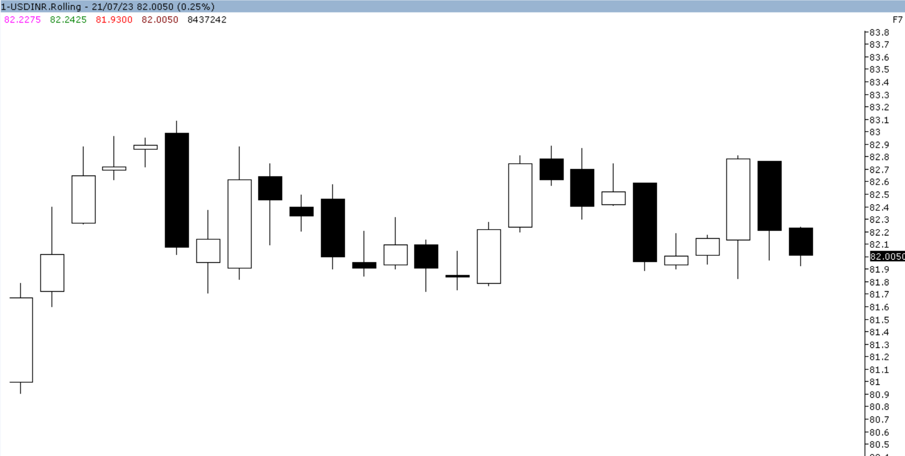
NSE USDINR Jul as seen in the weekly chart above has opened the week gap up at 82.22 level. Same day of the week price rallied and made weekly high of 82.2425 levels. Later on, price could not able to sustain on higher levels, it has corrected sharply and made a weekly low of 81.93 levels. This week prices have closed below previous week closing of 82.2075 levels, and finally closed 0.25% lower at 82.00 levels. Technically, prices have formed “Bearish candlestick pattern” which indicates further weakness.
For the next week, we expect USDINR prices to find support in the range of 81.40- 81.30 levels. Trading consistently below 81.30 levels,would lead towards the strong support at 80.80 levels and then finally towards major support at 80.40 levels.
Resistance is now observed in the range of 82.60 82.70 levels.Trading consistently above 82.70 levels, would lead towards the strong resistance at 83.20 levels and then finally towards the major resistance at 83.60 levels.
NSE USDINR trading levels for the week
Trend: Sideways to Down
S1 – 81.40 R1 – 82.60
S2 – 80.80 R2 – 83.20
Weekly Recommendation: Sell NSE USDINR July at 81.60- 81.70 SL – 82.60 TGT 81.40- 80.80.
MCX Gold Aug ( CMP – Rs. 59,309 / $ 1963.60 )

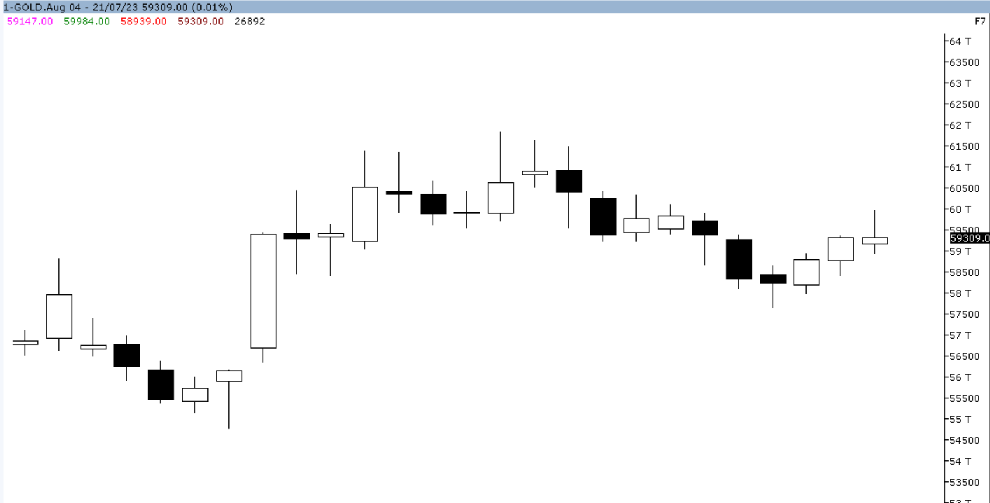
MCX GOLD Aug as seen in the weekly chart above has opened the week gap down at 59,147 levels. Same day of the week price corrected sharply and made a weekly low of 58,939 levels.Later on, price rallied sharply and made weekly high of 59,984 levels. This week prices have closed below previous week closing of 59,316 levels, and finally closed 0.01% lower at 59,309 levels. Technically, prices have formed “Doji candlestick pattern” which indicates further indecisiveness.
For the next week, we expect GOLD prices to find support in the range of 58,800- 58,700 levels.Trading consistently below 58,700 levels,would lead towards the strong support at 58,400 levels and then finally towards major support at 58,000 levels.
Resistance is now observed in the range of 59,800- 59,900 levels.Trading consistently above 59,900 levels,would lead towards the strong resistance at 60,300 levels and then finally towards the major resistance at 60,640 levels.
MCX / Spot Gold Trading levels for the week
Trend: Down
S1 – 58,800 / $ 1947 R1 – 59,800 / $ 1980
S2 – 58,400 / $ 1,934 R2 – 60,300 / $ 1997
Weekly Recommendation: Sell MCX Gold Aug at 59800- 59900 SL - 60300 TGT 59000- 58800.
;;;;;;;e7y
8i9u
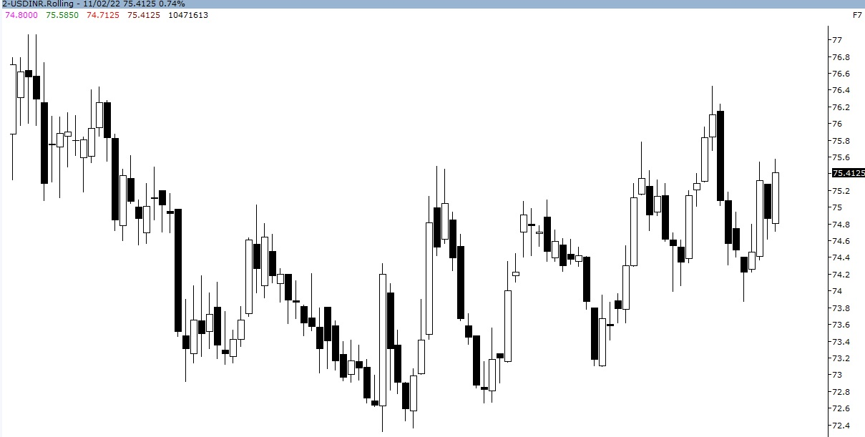
MCX Silver Sep (CMP – Rs. 74,970 / $ 24.78)

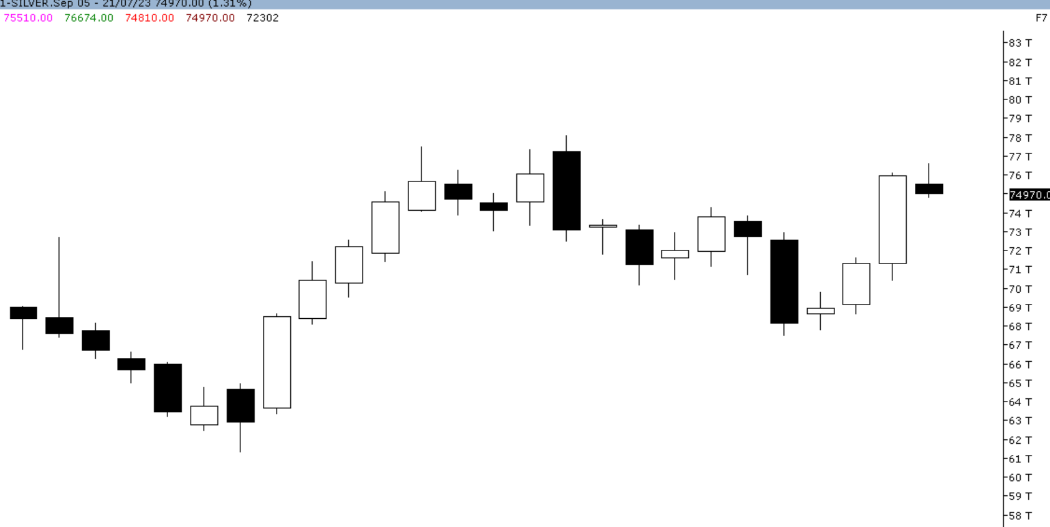
MCX SILVER Sep as seen in the weekly chart above has opened the week gap down at 75,510 level. Starting day of the week price rallied sharply and made a weekly high of 76,674 levels. Later on, price corrected sharply and made weekly low of 74,810 levels. This week prices have closed below previous week closing of 75,968 levels, and finally closed 1.31% lower at 74,970 levels. Technically, prices have formed “Bearish candlestick pattern” which indicates further weakness.
For the next week, we expect SILVER prices to find support in the range of 73,000- 72,800 levels.Trading consistently below 72,800 levels,would lead towards the strong support at 71,400 levels and then finally towards major support at 70,500 levels.
Resistance is now observed in the range of 77,000- 77,100 levels.Trading consistently above 77,100 levels, would lead towards the strong resistance at 78,700 levels and then finally towards the major resistance at 79,500 levels.
MCX / Spot Silver Trading levels for the week
Trend: Down
S1 – 73,000 / $ 24.14 R1 – 77,000 / $ 25,45
S2 – 71,400 / $ 23.60 R2 – 78,700 / $ 26.10
Weekly Recommendation: Sell MCX Silver Sep at 77000- 77100 SL - 78700 TGT 73500 – 73000.
p at 60,517 levels. Starting of the week price corrected sharply and made weekly low of 60,070 levels. Later on, price could not able to sustain on lower levels, it has rallied sharply and made a weekly high of 62,708 levels. This week prices have closed above previous week closing of 61,801 levels and finally closed 2.07% higher at 61,801 levels. Technically, prices have formed “Bullish candlestick pattern” which indicates further strength.
For the next week, we expect Silver prices to find support in the range of 61,400– 61,100 levels. Trading consistently below 61,100 levels would lead towards the strong support at 59,800 levels and then finally towards major support at 57,300 levels.
Resistance is now observed in the range of 62,700 –63,000 levels. Trading consistently above 63,000 levels would lead towards the strong resistance at 64,100 levels, and then finally towards the major resistance at 66,800 levels.
MCX / Spot Silver Trading levels for the week
Trend: Up
S1 – 59,800 / $ 21.60 R1 – 64,100 / $ 24.20
S2 – 57,300 / $ 20.20 R2 – 66,800 / $ 25.80
Weekly Recommendation: Buy MCX Silver Dec at 61400-61100 SL - 59800 Target 64100 –64600 00
MCX Copper Aug (CMP – Rs. 726.90 / $ 8485.50)
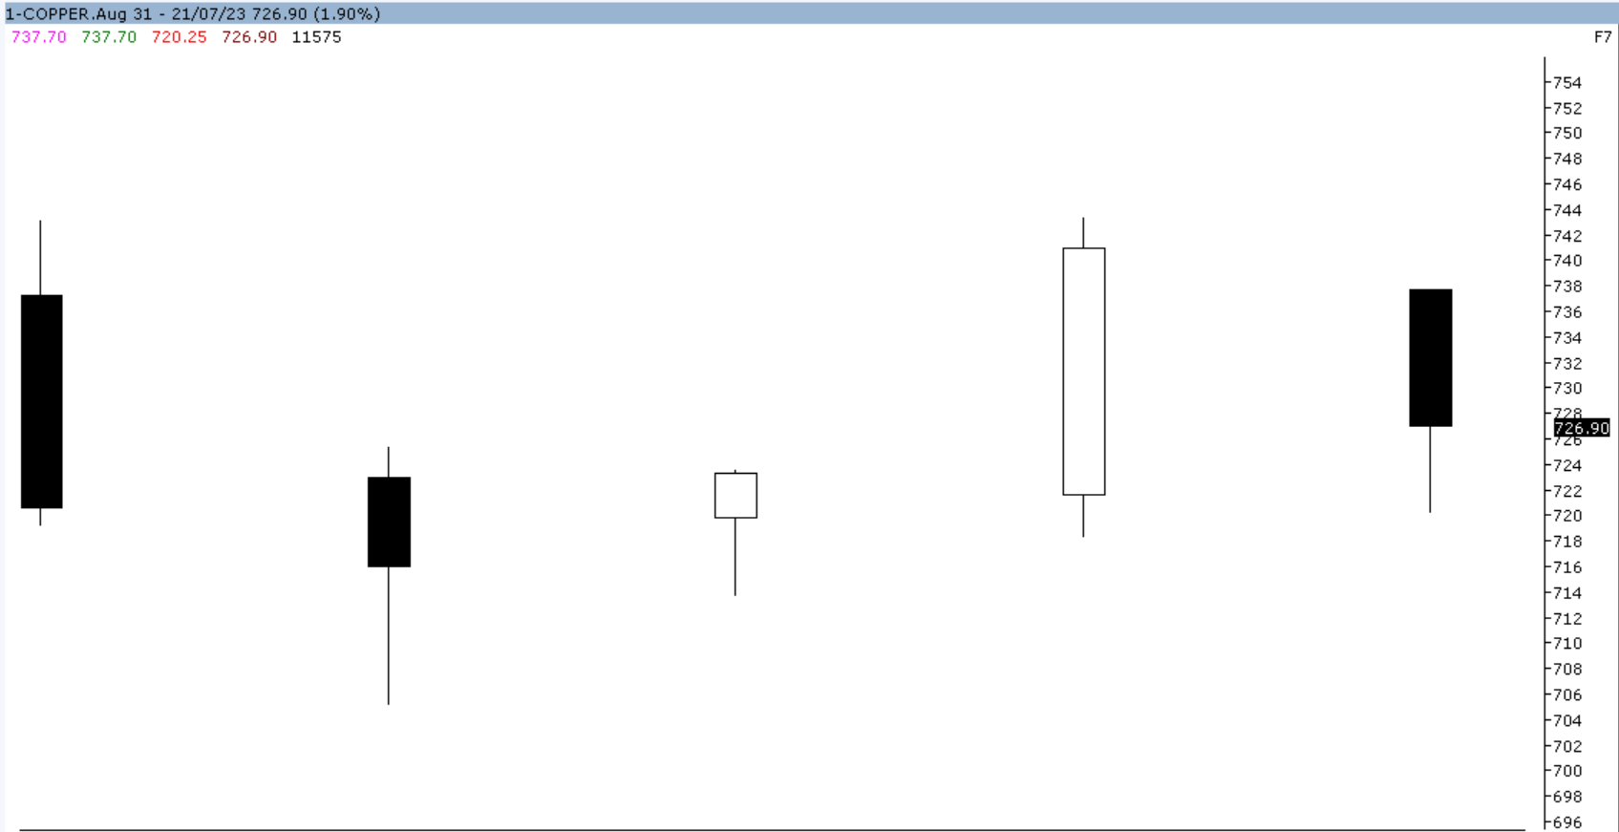
MCX COPPER Aug as seen in the weekly chart above has opened the week gap down at 737.70 levels. Open and week high remain same. Later on, price corrected sharply and made a weekly low of 720.25 levels.This week prices have closed below previous week closing of 740.95 levels, and finally closed 1.90% lower at 726.90 levels. Technically, prices have formed formed “Bearish candlestick pattern” which indicates further weakness.
For the next week, we expect COPPER prices to find support in the range of 712- 710 levels. Trading consistently below 710 levels, would lead towards the strong support at 700 levels and then finally towards major support at 692 levels.
Resistance is now observed in the range of 740- 742 levels. Trading consistently above 742 levels, would lead towards the strong resistance at 756 levels and then finally towards the major resistance at 769 levels.
MCX / LME Copper Trading levels for the week
Trend: Down
S1 – 712 / $ 8,340 R1 – 740 / $ 8,650
S2 – 700 / $ 8,130 R2 – 756 / $ 8,750
Weekly Recommendation: Sell MCX Copper July at 740 - 742 SL - 756 TGT 720- 712.

o

MCX Crude Oil Aug (CMP – Rs. 6,298 / $ 76.83)
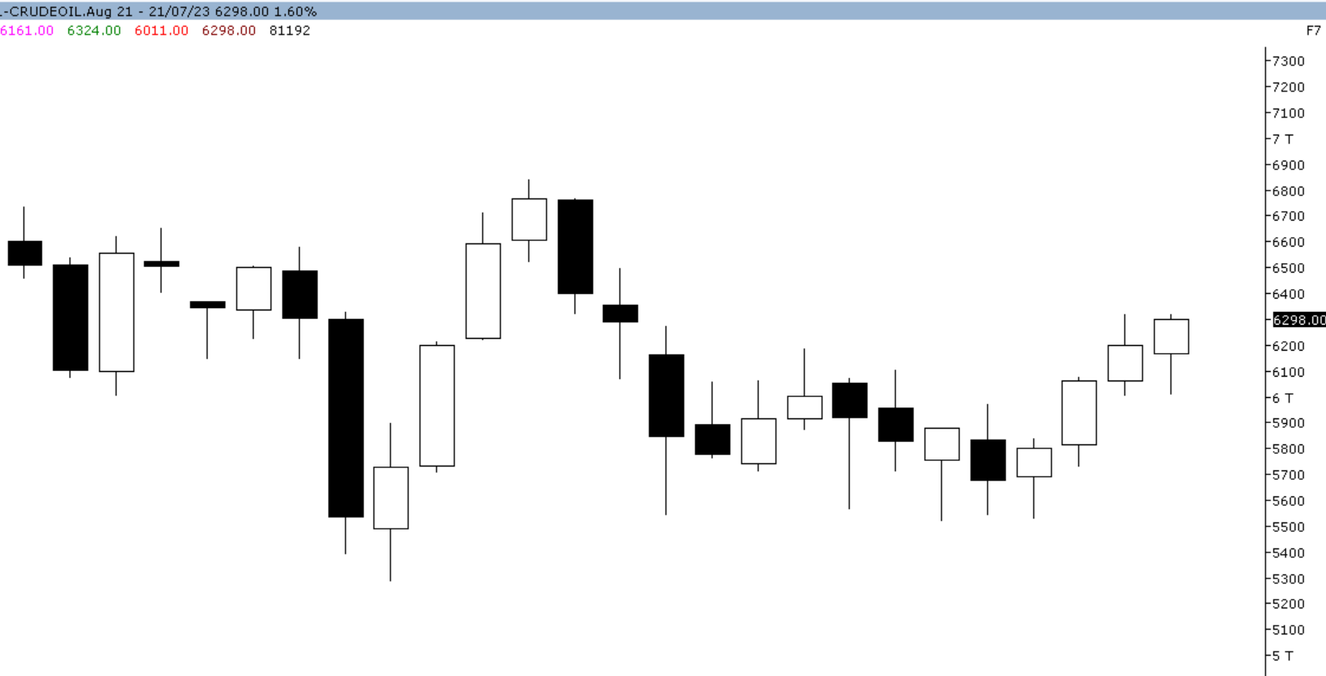
MCX CRUDEOIL Aug as seen in the weekly chart above has opened the week gap down at 6,161 levels. Same day of the week price corrected sharply and made a weekly low of 6,011 levels. Later on, price rallied sharply and made weekly high of 6,324 levels. This week prices have closed above previous week closing of 6,199 levels, and finally closed 1.60% higher at 6,298 levels. Technically, prices have formed “Bullish candlestick pattern” which indicates further strength.
For the next week, we expect CRUDEOIL prices to find support in the range of 6,140- 6,120 levels. Trading consistently below 6,120 levels,would lead towards the strong support at 6,010 levels and then finally towards major support at 5,810 levels.
Resistance is now observed in the range of 6,460- 6,480 levels. Trading consistently above 6,480 levels, would lead towards the strong resistance at 6,630 levels and then finally towards the major resistance at 6,660 levels.
MCX / NYMEX Crude Oil Trading levels for the Week
Trend: Sideways to Up
S1 – 6,140 / $ 74.90 R1 – 6460 / $ 78.70
S2 – 6,010 / $ 73.30 R2 – 6630 / $ 80.85
Weekly Recommendation: Buy Crude Oil Aug at 5140- 5120 SL - 6010 TGT 6400- 6460. 94.35
Weekly Recommendation: Buy MCX Crudeoil Feb at 6600- 6580 SL - 6300 Target 7050 –7100. 0 SL - 5370 Target 5800- 5840.

MCX Natural Gas July (CMP – Rs. 221.70 / $ 2.72)

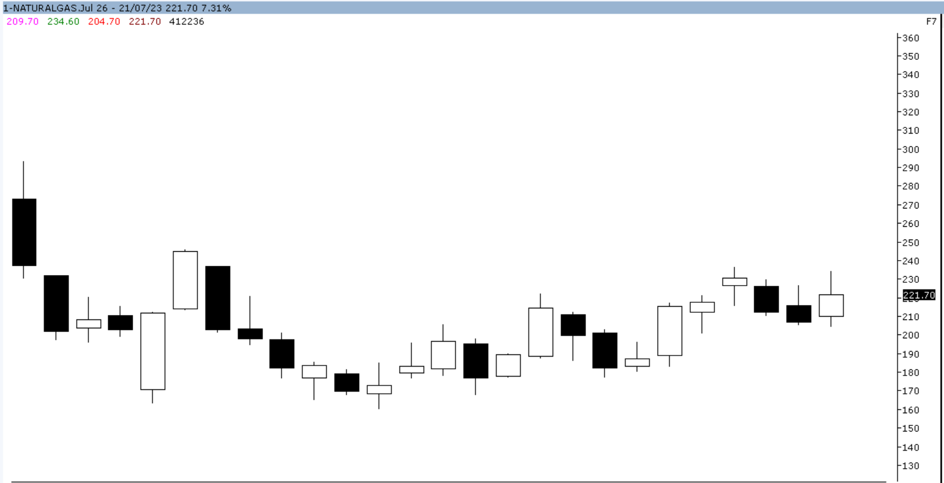
MCX NATURAL GAS Jul as seen in the weekly chart above has opened the week gap up at 209.70 level. Same day of the week price corrected and made weekly low of 204.70 levels. Later on, price could not be able to sustain on lower levels, it has rallied sharply and made a weekly low of 234.60 levels. This week prices have closed above previous week closing of 206.60 levels, and finally closed 7.31% higher at 221.70 levels. Technically, prices have formed “Bullish candlestick pattern” which indicates further strength.
For the next week, we expect NATURAL GAS prices to find support in the range of 210 -2108 levels. Trading consistently below 208 levels,would lead towards the strong support at 199 levels and then finally towards major support at 172 levels.
Resistance is now observed in the range of 239- 241 levels. Trading consistently above 241 levels, would lead towards the strong resistance at 250 levels and then finally towards the major resistance at 265 levels.
MCX / NYMEX Natural Gas Trading levels for the week
Trend: Sideways to Up
S1 – 210 / $ 2.56 R1 – 239 / $ 2.92
S2 – 199 / $ 2.43 R2 – 250 / $ 3.05
Weekly Recommendation: Buy Natural Gas July at 210- 208 SL - 199 TGT 235- 239. . tance at 243 levels.
MCX / NYMEX Natural Gas Trading levels for the week
Trend: Sideways
S1 – 209 / $ 2.90 R1 – 225 / $ 3.10
S2 – 200 / $ 2.75 R2 – 234 / $ 3.25
Weekly Recommendation: Neutral
99
Prepared by
Tejas Anil Shigrekar  Sr, Technical Research  Tejas.shigrekar@angelone.com  Board line:4000 3600 Extn: 6123 | Manish Kumar Pargi  Sr, Technical Research  manishkumar.pargi@angelone.com  Board line:4000 3600 Extn: 612
Angel One Ltd.
Registered Office: G-1, Ackruti Trade Centre, Rd. No. 7, MIDC, Andheri (E), Mumbai - 400 096.
Corporate Office: 6th Floor, Ackruti Star, MIDC, Andheri (E), Mumbai - 400 096. Tel: (022) 2921 2000
MCX Member ID: 12685 / FMC Regn No: MCX / TCM / CORP / 0037 NCDEX: Member ID 00220 / FMC Regn No: NCDEX / TCM / CORP / 0302

Disclaimer: The information and opinions contained in the document have been compiled from sources believed to be reliable. The company does not warrant its accuracy, completeness and correctness. The document is not, and should not be construed as an offer to sell or solicitation to buy any commodities. This document may not be reproduced, distributed or published, in whole or in part, by any recipient hereof for any purpose without prior permission from “Angel One Ltd”. Your feedback is appreciated on advisory@angelone.com

